## MONITORING TOXIC GASES USING NANOTECHNOLOGY AND WIRELESS SENSORS

A project report submitted to

**JAWAHARLAL NEHRU TECHNOLOGICAL UNIVERSITY, KAKINADA**

In partial fulfilment of the requirements for the award of the degree of

**BACHELOR OF TECHNOLOGY**

**In**

**ELECTRONICS AND COMMUNICATION ENGINEERING**

Submitted by

**B. DEVISREE (21NR5A0406)**

**T.VSAI KIRAN (20NR1A0472)**

**R. SRI RAM (20NR1A0458)**

**N. NAVYA PRIYA (21NR5A0418)**

**Under the esteemed Guidance of**

**Dr.Y. V. BHASKARA LAKSHMI,**

**M.Tech,Ph.D,**

**Professor, Dept. of ECE**

**DEPARTMENT OF ELECTRONICS AND COMMUNICATION ENGINEERING**

### BABA INSTITUTE OF TECHNOLOGY AND SCIENCES

(Approved by AICTE, New Delhi & Affiliated to JNTU, Kakinada, A.P) Bakkannapalem(V), Madhurawada, Visakhapatnam – 530048

### 2020-2024

**DEPARTMENT OF ELECTRONICS AND COMMUNICATION ENGINEERING**

### BABA INSTITUTE OF TECHNOLOGY AND SCIENCES

(Approved by AICTE, New Delhi & Affiliated to JNTU, Kakinada, A.P) Bakkannapalem(V), Madhurawada, Visakhapatnam – 530048



## CERTIFICATE

This is to certify that the project work entitled

**“MONITORING TOXIC GASES USING NANO TECHNOLOGY AND WIRELESS SENSORS”**

is a bonafide record of work done by

**B. DEVISREE (Regd.No.21NR5A0406), T. SAI KIRAN (Regd.No.20NR1A0472), R. SRIRAM (Regd.No.20NR1A0458), N. NAVYA PRIYA (Regd.No.21NR5A0418),** under the supervision of **Dr. Y. V. BHASKARA LAKSHMIM.Tech, Ph.D, Dept. of ECE** for the partial fulfilment for the award of the degree of **BACHELOR OF TECHNOLOGY** in Electronics and Communication Engineering at **Jawaharlal Nehru Technological University, GurajadaVijayanagaram** during the academic years 2021– 2024.

**Project Guide Head of The Department**

**Dr. Y. V. BHASKARA LAKSHMI Mr. K.PRADEEP M.Tech, (Ph. D),**

**M.Tech, Ph.D**

**Associate Professor**, **Associate Professor**,

**External Examiner**

**DECLARATION**

We are the students hereby declare that the work which is being presented in this dissertation entitled “**MONITORING TOXIC GASES USING NANO TECHNOLOGY AND WIRELESS SENSORS**” submitted towards the partial fulfillment of the requirements for the award of the degree of Bachelor of Technology in Electronics and Communication Engineering, is an authentic record of our work carried out under the supervision of **Dr. Y. V. BHASKARA LAKSHMI, M.Tech, Ph.D, Associate Professor** in the Department of Electronics and Communication Engineering, Baba Institute of Technology and Sciences affiliated to **JNTU GURAJADA VIZIANAGARAM**.

The matter embodied in this dissertation report has not been submitted by me for the award of any other degree. Further the technical details furnished in the various chapters in these reports are purely relevant to the above project and there is no deviation from the theoretical point of view for implementation..

|  |  |  |
| --- | --- | --- |
|  | **Project Members** |  |
| **B. DEVISREE** |  | **(21NR5A0406)** |
| **T. SAI KIRAN** |  | **(20NR1A0472)** |
| **R. SRI RAM** |  | **(20NR1A0458)** |
| **N. NAVYA PRIYA** |  | **(21NR5A0418)** |
|  |  |  |

## ACKNOWLEDGEMENT

We express our grateful thanks to the BITS Vizag organization, which has helped us to complete our project. It is a great pleasure and an opportunity for us to express our deep sense of gratitude to all those who have made it possible for us to accomplish our project work successfully.

We are highly indebted to our Guide and Head of the Department **Mr. K.PRADEEP M.Tech, (Ph. D), Associate Professor**, and Project Coordinator **Dr. Y. V. BHASKARA LAKSHMI, M.Tech, Ph.D, Associate Professor**, Baba Institute of Technology and Sciences, for giving us an opportunity to work under him by giving his valuable suggestions, sustained supervision, sagacious guidance, steady encouragement throughout the project work.

We are sincerely thankful for the encouraging attitude of **Dr. M. Govindha Raju**, Principal, **Baba Institute of Technology and Sciences.** We also thankful to all the **STAFF** of the Department of Electronics and Communication Engineering for their cooperation and encouragement during the process of the mini project work.

We express sincere thanks to **Dr. K. SRI LAKSHMI**, Secretary and Correspondent of **Baba Institute of Technology and Sciences,** for her support and supervision for the enrichment of the entire work.

|  |  |  |
| --- | --- | --- |
|  | **Project Members** |  |
| **B. DEVISREE** |  | **(21NR5A0406)** |
| **T. SAI KIRAN** |  | **(20NR1A0472)** |
| **R. SRI RAM** |  | **(20NR1A0458)** |
| **N. NAVYA PRIYA** |  | **(21NR5A0418)** |
|  |  |  |

|  |  |  |
| --- | --- | --- |
| **CONTENTS** | |  |
| **LISTOF FIGURES** | | I-II |
| **LISTOF TABLES** | | III |
| **ABBREVIATIONS** | | IV |
| **ABSTRACT** | | V |
| **Chapter 1.** | **INTRODUCTION** | **1** |
| 1.1 | CAUSES OF TOXIC GASES | 2 |
| 1.2 | TOXIC GAS DETECTION | 3 |
| 1.3 | NANOTECHNOLOGY | 3 |
| 1.4 | WIRELESS NETWORKS | 4 |
| 1.4 | LITERATURE SURVEY | 5 |
| 1.5 | MOTIVATION | 10 |
| 1.6 | OVERVIEW OF THE PROJECT | 10 |
| 1.7 | OBJECTIVE | 11 |
| 1.8 | METHODOLOGY | 11 |
|  |  |  |
| **Chapter 2.** | HARMFUL GAS DETECTION AND MONITORING SYSTEM USING IOT SYSTEM | **13** |
| 2.1 | WORKING PRINCIPLE | 14 |
| 2.2 | HARDWARE USED | 15 |
| 2.3 | SOFTWARE USED | 16 |
| 2.4 | ALGORITHM | 19 |
| 2.3 | LIMITATIONS OF THE EXISTING SYSTEM | 19 |
| **Chapter 3.** | **PROPOSED SYSTEM** |  |
| 3.1 | MONITORING TOXIC GASES USING NANOTECHNOLOGY AND WIRELESS SENSORS | 14 |
| 3.2 | OBJECTIVE | 14 |
| 3.3 | BLOCK DIAGRAM OF PROPOSED SYSTEM | 15 |
| 3.4 | ARDUINO | 16 |
|  | 3.4.1 FEATURES OFARDUINO UNO | 17 |
|  | 3.4.2 ARDUINO UNO PIN DESCRIPTION | 18 |
|  | 3.4.3 ADVANTAGES OFARDUINO | 20 |
|  | 3.4.4 HOW TO USE ARDUINO | 21 |
|  | 3.4.5 ARDUINO PROGRAMMING | 21 |
|  | 3.4.6 HIGH VOLTAGE PROTECTION OF USB | 22 |
|  | 3.4.7 APPLICATIONS OF ARDUINO UNO | 22 |
| 3.5 | MICROCONTROLLER | 22 |
|  | 3.5.1 INPUT AND OTPUT PORTS |  |
|  | 3.5.2 APPLICATIONS OF MICROCONTROLLER |  |
| 3.6 | MQ135 SENSOR |  |
|  | 3.6.1 DETAILS OF MQ135 SENSOR |  |
|  | 3.6.2 PIN CONFIGUARTION MQ135 GAS SENSOR |  |
|  | 3.6.3 SPECIFICATINS OF MQ135 SENSOR |  |
|  | 3.6.4 MEASURE PPM VALUE USING ANALOG PIN |  |
| 3.7 | MQ2 GAS SENSOR |  |
| 3.8 | DHT11 SENSOR |  |
|  | 3.8.1 TECHNICAL SPECIFICATION |  |
| 3.9 | ALPHANUMERIC LCD |  |

|  |  |  |
| --- | --- | --- |
| 3.10 | GSM MODULE |  |
|  | 3.10.1 GSM ARCHITECTURE |  |
|  | 3.10.2 FEATURES OF GSM MODULE |  |
|  | 3.10.3 GSM MODEM |  |
|  | 3.10.4 WIRELESS MODEM |  |
|  | 3.10.5 GSM/GPRS MODEM |  |
|  | 3.10.6 AT COMMANDS |  |
| 3.11 | BUZZER DRIVER CIRCUIT |  |
| 3.12 | POWER SUPLY |  |
|  | 3.12.1 INTRODUCTION |  |
|  | 3.12.2 TRANSFORMER |  |
|  | 3.12.3 RECTIFIER |  |
|  | 3.12.4 SMOOTHING |  |
|  | 3.12.5 REGULATOR |  |
| 3.13 | LED |  |
| 3.14 | CIRCUIT DIAGRAM |  |
| 3.15 | ADVANTAGES |  |
| 3.16 | APPLICATIONS­- |  |
|  | 3.12.1 INTRODUCTION |  |
|  | 3.12.2 TRANSFORMER |  |
| **Chapter 4.** | **RESOURCES USED** |  |
| 4.1 | ARDUINO IDE |  |
| 4.1.1 | WRITINGSKETCHES |  |
| 4.1.2 | FILE | 61 |
| 4.1.3 | EDIT | 62 |
| 4.1.4 | SKETCH | 63 |
| 4.1.5 | TOOLS | 64 |
| 4.1.6 | HELP | 64 |
| 4.1.7 | SKETCHBOOK | 65 |
| 4.1.8 | UPLOADING | 65 |
| 4.1.9 | LIBRARIES | 66 |
| 4.1.10 | SERIALMONITOR | 66 |
|  |  | 66 |

|  |  |  |
| --- | --- | --- |
| 4.2 | EMBEDDEDCLANGUAGE | 67 |
|  | 4.2.1 EMBEDDEDSYSTEMPROGRAMMING | 67 |
|  | 4.2.2 MAINFACTORS OF EMBEDDED C PROGRAM | 68 |
|  | 4.2.3 STEPS TO BUILD AN EMBEDDDED C PROGRAM | 69 |
|  | 4.2.4 BENEFITS OF EMBEDDEDC |  |
|  | 4.2.5 APPLICATIONS OF EMBEDDED C |  |
| **Chapter 5.** | **EXPERIMENTAL RESULTS** |  |
| 5.1 | HARDWARE IMPLEMENTATIONS 74 |  |
| 5.2 | SOFTWARE MPLEMENTATIONS 78 |  |
| 5.3 | APPLICATIONS 79 |  |
| 5.4 | SIGNIFICANCE |  |
| **CONCLUSION** | |  |
| **FUTURESCOPE** | |  |
| **BIBLIOGRAPHY** | |  |

## LISTOFFIGURES

### FIG.NO DESCRIPTION PAGENO

* 1. BLOCK DIAGRAM OF EXISTING SYSTEM 11
  2. BLOCK DIAGRAM OF PROPOSED SYSTEM 15
  3. ARDUINO UNO 26
  4. PINOUT OF ARDUINO UNO 18
  5. INPUT & OUTPUT PORTS 32
  6. DETAILS OF MQ135 SENSOR 34
  7. PIN CONFIGURATION MQ135 GAS SENSOR 36
  8. MEASURE PPM VALUE ANLOG PIN 38
  9. DHT11 SENSOR 42
  10. TECHNOCAL SPECIFICATONS 45
  11. BLOCK DIAGRAM OF A REGULATED POWER SUPPLY SYSTEM 46
  12. OUTPUT WAVEFORM TRANSFORMER 46
  13. RECTIFIER CIRCUIT 47
  14. OUTPUT OF RECTIFIER
  15. SMOOTHING ACTION OF CAPACITOR
  16. WAVE FORM OF THE RECTIFIED OUTPUT SMOOTHING
  17. LED IMAGE AND SYMBOL
  18. LED INTERFACING CIRCUIT
  19. GLOBAL POSITIONING SYSTEM 50
  20. GLOBAL SYSTEM FOR MOBILE COMMUNICATION 52
  21. GSM MODULE 54
  22. GSM ARCHITECTURE 56
  23. CIRCUIT DIAGRAM OF PROPOSED SYSTEM 58
  24. ARDUINO IDE 60
  25. PROJECT BATCH MEMBERS 74
  26. HARDWARE IMPLEMENTATION 75
  27. SHOWING LOCATION OF PATIENT ON MOBILE 76
      + **IoT:** Internet of Things
      + **Arduino IDE:** Arduino Integrated Development Environment
      + **IHMS:** Intelligent Health Monitoring System
      + **LCD:** Liquid Crystal Display
      + **BPM:** Beats Per Minute
      + **LED:** Light Emitting Diode
      + **EDA:** Electronic Design Automation
      + **GSM:** Global System for Mobile Communication

Human beings live and work in close proximity to dangerous gases. Chemical accidents often cause considerable damages to human lives as well as properties and their short- and long-term impact on the environment can be high. Hence, diligent monitoring and management of these gases are of profound importance. In industries where chemical accidents pose potential explosions and health hazards, wired sensors are installed in strategic locations. In some industries, employees are required to carry with them portable sensing devices in addition. Still, achieving high spatio-temporal resolution is challenging, since dense deployments impede the mobility of employees, robots, or other mobile objects. In this paper, we propose the use of nanotechnology and wireless sensor networks for monitoring toxic gases. Nanotechnology offers the possibility of developing gas sensors having small form-factors and high sensitivity. Wireless sensor networks enable high spatio-temporal sensing, in-network processing, and multi-hop communications. Thepapersharesourexperiencewithawirelesssensornetworkmonitoringammonia.Thenetworkconsistedof21sensor nodes, four of which integrated arrays of ammonia sensors while the rest served as intermediate nodes.

**Index Terms**-Ammonia, hydrogensulphate, latency, monitoring, multihop communication, nanosensors, nanotechnology, response time, toxic gas detection, wireless sensor network

# CHAPTER-1

# INTRODUCTION

**CHAPTER-1**

**INTRODUCTION**

* 1. **CAUSES OF TOXIC GASES**

The increase in the development of technology and the human race, we failed to take care about the surroundings in which we live in. Thus we polluted the environment and thereby reducing the quality of the place we live. Even though there are several aspects of pollution such as soil, air and water pollution, out of these air pollution acts as the serious aspect as the other can detected visually and by taste, but the polluted air cannot be detected as it can be odorless, tasteless and colorless. Hence there is a growing demand for the environmental pollution monitoring and control systems. In the view of the ever-increasing pollution sources with toxic chemicals, these systems should have the facilities to detect and quantify the sources rapidly. Toxic gases are one that causes serious health impacts, but are also used in industries in large quantities. These gases have to be monitored; such that increase in the normal level of them could be known and proper precaution measures can be taken. But the current systems available are not so portable and are costly and difficult to implement. Hazardous gases refer to all kinds of gas that can be potential harmful to humans in certain concentrations. The major harmful gases such as CO2, NO2, SO2, CO that evolve from the drainage not only effect the environment but also the natural habitat. The various impacts are environmental impacts, human health impacts and economic impacts. The environmental impacts include, Overall average annual temperatures are expected to increase and Global warming will decrease snow, sea ice and glacier coverage, resulting in rising sea levels and increased coastal flooding.

* 1. **TOXIC GAS DETECTION**

The toxic gases like carbon monoxide, methane, hydrogen sulphide which is emitted from the drainage wastes. While cleaning the drainage these gases are emitted. The emitted gases are inhaled by the workers in drainage cleaning and it causes a major health effects. The effects like skin allergies, nervous system blockage, aphysixation etc. These toxic gases which give these effects based on their concentration in drainage wastes. If the gas concentration are more than the threshold value it may cause to death also. Hence these gases are sensed by the different sensors and it should be given to the microcontroller to alert the workers by alarm indication. If the sensor value is greater than the threshold value the microcontroller gives the signal to alarm to indicate the warning to labours. This system will help to keep the workers from the effect of toxic gases.

* 1. **NANOTECHNOLOGY**

**Nanotechnology**, the manipulation and manufacture of materials and devices on the scale of atoms or small groups of atoms. The “nanoscale” is typically measured in nanometres, or billionths of a metre (nanos, the Greek word for “dwarf,” being the source of the prefix), and materials built at this scale often exhibit distinctive physical and chemical properties due to [quantum mechanical](https://www.britannica.com/science/quantum-mechanics-physics) effects. Although usable devices this small may be decades away (see [microelectromechanical system](https://www.britannica.com/technology/microelectromechanical-system)), techniques for working at the nanoscale have become essential to electronic [engineering](https://www.britannica.com/technology/engineering), and nanoengineered materials have begun to appear in consumer products. For example, billions of microscopic “nano whiskers,” each about 10 nanometres in length, have been molecularly hooked onto natural and [synthetic](https://www.merriam-webster.com/dictionary/synthetic) fibres to impart stain resistance to [clothing](https://www.britannica.com/topic/dress-clothing) and other fabrics; zinc oxide nanocrystals have been used to create invisible sunscreens that block ultraviolet light; and silver nanocrystals have been embedded in bandages to kill bacteria and prevent infection.

Possibilities for the future are numerous. Nanotechnology may make it possible to manufacture lighter, stronger, and programmable materials that require less energy to produce than conventional materials, that produce less waste than with conventional [manufacturing](https://www.britannica.com/technology/manufacturing), and that promise greater fuel [efficiency](https://www.merriam-webster.com/dictionary/efficiency) in land [transportation](https://www.britannica.com/technology/transportation-technology), ships, aircraft, and space vehicles. Nanocoatings for both [opaque](https://www.merriam-webster.com/dictionary/opaque) and translucent surfaces may render them resistant to corrosion, scratches, and radiation. Nanoscale electronic, magnetic, and mechanical devices and systems with unprecedented levels of [information processing](https://www.britannica.com/technology/information-processing) may be fabricated, as may chemical, photochemical, and biological sensors for protection, health care, manufacturing, and the environment; new photoelectric materials that will enable the manufacture of cost-efficient solar-energy panels; and molecular-semiconductor hybrid devices that may become engines for the next revolution in the information age. The potential for improvements in health, [safety](https://www.britannica.com/topic/safety-condition), [quality of life](https://www.britannica.com/topic/quality-of-life), and conservation of the [environment](https://www.merriam-webster.com/dictionary/environment) are vast.

### WIRELLES NETWORKS

The wireless communication revolution is bringing fundamental changes to data networking, telecommunication, and is making integrated networks a reality. By freeing the user from the cord, personal communications networks, wireless LAN's, mobile radio networks and cellular systems, harbor the promise of fully distributed mobile computing and communications, any time, anywhere.

Focusing on the networking and user aspects of the field, Wireless Networks provides a global forum for archival value contributions documenting these fast growing areas of interest. The journal publishes refereed articles dealing with research, experience and management issues of wireless networks. Its aim is to allow the reader to benefit from experience, problems and solutions described.

### LITERATURE SURVEY

* + - **M. Y. Aalsalem, W. Z. Khan, W. Gharibi, M. K. Khan, and Q. Arshad, “Wireless sensor networks in oil and gas industry: Recent advances, taxonomy, requirements, and open challenges,”,2018**

This project, conducted by M. Y. Aalsalem et al., explores the application of wireless sensor networks (WSNs) within the oil and gas industry, offering a comprehensive analysis of recent advancements, taxonomy, requirements, and open challenges in this domain. Through a thorough examination of existing literature and research, the authors provide insights into the potential benefits and limitations of deploying WSNs in such critical industrial settings. By delineating the taxonomy of WSNs and their relevance to the oil and gas sector, the paper contributes to a deeper understanding of how these technologies can be effectively utilized for monitoring and managing various processes, including exploration, production, and distribution. Furthermore, the authors highlight the specific requirements and considerations that must be addressed when implementing WSNs in oil and gas operations, such as reliability, scalability, and security. Additionally, the paper identifies and discusses the open challenges that still need to be tackled, such as energy efficiency, data management, and integration with existing infrastructure. Overall, this project serves as a valuable resource for researchers, engineers, and industry professionals seeking to leverage wireless sensor networks for enhanced efficiency, safety, and sustainability in the oil and gas industry.

* + - **X. Chao, W. Dargie, and G. Lin, “Energy model for H2S monitoring wireless sensor network,”, 2008**

In this project by X. Chao et al., an energy model for monitoring hydrogen sulfide (H2S) using wireless sensor networks (WSNs) is developed. The study focuses on understanding and optimizing energy consumption, a critical factor in WSNs' performance and longevity. By proposing an energy model specifically tailored for H2S monitoring, the authors address the unique requirements and challenges associated with this application, such as the need for continuous monitoring in potentially hazardous environments. The model likely incorporates factors like transmission power, data aggregation techniques, and sleep scheduling to maximize energy efficiency while ensuring reliable and timely data collection. This research contributes to the broader goal of improving the sustainability and effectiveness of WSN deployments for environmental monitoring, particularly in industries where gas detection is paramount for safety and compliance..

* + - **A. Valera-Medina, H. Xiao, M. Owen-Jones, W. I. David, and P. Bowen, “Ammonia for power,”, 2018**

In their project titled "Ammonia for power," Valera-Medina et al. explore the potential of using ammonia as a fuel source for power generation. The study provides a comprehensive review of the current state of knowledge regarding the use of ammonia in combustion processes, focusing on its suitability as a sustainable alternative to traditional fossil fuels. By examining various aspects such as combustion characteristics, emissions profile, and combustion technologies, the authors assess the feasibility and challenges associated with utilizing ammonia for power generation. This research contributes valuable insights into the development of cleaner and more sustainable energy systems, offering potential solutions to address climate change and reduce reliance on fossil fuels. Additionally, the project likely discusses ammonia's role in emerging technologies like fuel cells and its potential for integration into existing energy infrastructure. Overall, the study provides a critical evaluation of the opportunities and limitations of adopting ammonia as a viable energy source, highlighting its importance in the transition towards a more sustainable energy future.

* + - **P. Zhao, Z. Li, X. Han, and X. Duan, “Supply chain network resilience by considering disruption propagation: Topological and operational perspectives,”, 2022**

In their project titled "Supply chain network resilience by considering disruption propagation: Topological and operational perspectives," Zhao et al. delve into enhancing supply chain resilience by investigating disruption propagation from both topological and operational viewpoints. The study likely examines how disruptions in one part of the supply chain network can propagate and affect the overall system's resilience. By integrating both topological aspects, which involve the structure and connectivity of the supply chain network, and operational perspectives, which focus on dynamic responses and recovery strategies, the authors aim to provide a comprehensive understanding of resilience enhancement strategies. This research contributes to the development of robust supply chain management practices, offering insights into mitigating the impacts of disruptions and improving overall system performance and adaptability. Additionally, the project likely explores the application of advanced modeling techniques and optimization algorithms to support decision-making processes for enhancing supply chain resilience in the face of uncertainty and unforeseen events. Overall, the study presents a holistic approach to supply chain resilience, addressing both structural and operational considerations to build more resilient and adaptive supply chain networks..

* + - **H. Yilmazkuday, “Coronavirus disease 2019 and the global economy,”, 2022**

In "Coronavirus disease 2019 and the global economy" by H. Yilmazkuday, the impact of the COVID-19 pandemic on the global economy is investigated within the context of transport policy. The study likely analyzes the far-reaching effects of the pandemic on various aspects of the economy, including trade, transportation, and supply chains. Through empirical analysis and theoretical frameworks, the author examines how the pandemic-induced disruptions have influenced economic activity, employment, and income distribution worldwide. Additionally, the project likely discusses policy responses implemented by governments and international organizations to mitigate the economic fallout and support recovery efforts. This research contributes valuable insights into the complex interplay between public health crises and economic systems, highlighting the need for coordinated and adaptive policy measures to address the challenges posed by the pandemic. Overall, the study provides a comprehensive assessment of the pandemic's impact on the global economy, offering implications for policymakers, businesses, and stakeholders navigating the post-pandemic landscape.

* + - **B. Zhang, Y. Liu, and S. Qiao, “A quantitative individual risk assessment method in process facilities with toxic gas release hazards: a combined scenario set and cfd approach,”,2019**

In their project titled "A quantitative individual risk assessment method in process facilities with toxic gas release hazards: a combined scenario set and CFD approach," Zhang et al. propose a novel methodology for quantitatively assessing individual risk in process facilities exposed to toxic gas release hazards. The study likely integrates scenario-based analysis and computational fluid dynamics (CFD) modeling to evaluate the potential risks posed to individuals working in such environments. By considering various release scenarios and simulating the dispersion of toxic gases, the authors aim to provide a comprehensive understanding of the potential consequences and probabilities of harm to workers. This research contributes to advancing safety protocols and risk management practices in industrial settings, offering a systematic approach to identify and mitigate hazards associated with toxic gas releases. Additionally, the project likely discusses the practical implications of the proposed methodology for regulatory compliance, emergency response planning, and facility design optimization. Overall, the study presents a robust framework for assessing individual risk in process facilities, enhancing safety measures and ensuring the well-being of workers in hazardous environments.

* + - **W.-F. Cheung, T.-H. Lin, and Y.-C. Lin, “A real-time construction safety monitoring system for hazardous gas integrating wireless sensor network and building information modeling technologies,”,2018**

In their project titled "A real-time construction safety monitoring system for hazardous gas integrating wireless sensor network and building information modeling technologies," Cheung et al. propose a cutting-edge solution for enhancing safety in construction sites exposed to hazardous gas risks. The study likely presents an innovative system that integrates wireless sensor networks (WSNs) and building information modeling (BIM) technologies to enable real-time monitoring of gas levels and safety conditions. By leveraging WSNs, the system can continuously collect data on gas concentrations across the construction site, while BIM technologies provide a digital representation of the site's layout and structures. This integration allows for proactive identification of potential hazards and prompt response to mitigate risks, thereby improving overall safety for workers and personnel on-site. Furthermore, the project likely discusses the practical implementation of the monitoring system, including sensor deployment strategies, data processing algorithms, and user interface design. This research contributes to advancing construction safety practices, offering a comprehensive and technology-driven approach to managing hazardous gas risks in real-time. Overall, the study presents a promising solution to enhance safety and efficiency in construction operations, aligning with industry trends towards digitization and automation for improved workplace safety.

* + - **J. Chang, H. Meng, C. Li, J. Gao, S. Chen, Q. Hu, H. Li, and L. Feng, “A wearable toxic gas-monitoring device based on triboelectric nano- generator for self-powered aniline early warning,”,2020**

In their project titled "A wearable toxic gas-monitoring device based on triboelectric nanogenerator for self-powered aniline early warning," Chang et al. introduce an innovative wearable device for monitoring toxic gases, particularly aniline, that leverages triboelectric nanogenerator (TENG) technology. The study likely describes a compact and lightweight device that can be worn comfortably by individuals in various settings, such as industrial workplaces or laboratories. By harnessing the triboelectric effect, the device generates electrical power from mechanical motion, eliminating the need for external power sources and enabling self-sustainability. This self-powered feature ensures continuous operation and real-time monitoring of aniline concentrations, providing early warnings to users in the event of hazardous exposure. Furthermore, the project likely discusses the device's sensitivity, accuracy, and response time, demonstrating its effectiveness in detecting aniline gas at low concentrations. This research contributes to advancing wearable technology for personal safety applications, offering a practical solution for early detection of toxic gas exposure in potentially high-risk environments. Overall, the study presents a promising avenue for the development of self-powered wearable devices that enhance workplace safety and protect individuals from hazardous substances.

* + - **N. Asthana and R. Bahl, “IoT device for sewage gas monitoring and alert system,**” **2019**

In their project titled "IoT device for sewage gas monitoring and alert system," Asthana and Bahl introduce an innovative solution for monitoring sewage gas emissions using Internet of Things (IoT) technology. The study likely describes the development of a compact and wireless IoT device that can be deployed in sewage systems to continuously monitor gas levels. By leveraging sensors and connectivity capabilities, the device collects real-time data on gas concentrations, enabling early detection of potential hazards such as methane or hydrogen sulfide. Additionally, the project likely outlines an alert system that notifies relevant stakeholders, such as maintenance personnel or local authorities, in the event of abnormal gas levels, facilitating timely intervention and preventive measures. This research contributes to improving public health and environmental safety by providing a proactive approach to monitoring and managing sewage gas emissions. Overall, the study presents a practical application of IoT technology in addressing environmental challenges and enhancing infrastructure resilience.

* + - ] **L. A. Panes-Ruiz, L. Riemenschneider, A. Chawa, M. Moner, M. Loef- fler, B. Rellinghaus, R. Tetzlaff, V. Bezugly, B. Ibarlucea, and G. Cu- niberti, “Selective and self-validating breath-level detection of hydrogen sulfide in humid air by gold nanoparticle-functionalized nanotube ar- rays,”2022**

In their project titled "Selective and self-validating breath-level detection of hydrogen sulfide in humid air by gold nanoparticle-functionalized nanotube arrays," Panes-Ruiz et al. present a novel approach for detecting hydrogen sulfide (H2S) at breath level concentrations in humid air. The study likely describes the development of a highly sensitive and selective sensor system based on gold nanoparticle-functionalized nanotube arrays. These nanomaterials offer unique properties that enable the selective adsorption and detection of H2S molecules even in the presence of humidity, a common challenge in gas sensing applications. Additionally, the project likely discusses the self-validating mechanism employed by the sensor system, which ensures the accuracy and reliability of the detected H2S concentrations. This research contributes to advancing gas sensing technology for medical and environmental applications, offering a promising solution for early detection of H2S-related health risks in humid environments. Overall, the study demonstrates the potential of nanomaterial-based sensors for selective and sensitive detection of toxic gases, paving the way for improved safety and health monitoring capabilities.

### MOTIVATION

* + - * We know that many or almost all peoples does not switch off their vehicles at traffic signals when signal getting red. At that time smoke is emitted by vehicles causes more pollution and it is harmful for peoples who are walking on footpath, beggar's lives at footpath as well as traffic police also. So, in our system we just collect all the smoke emitted by vehicle at signals through pipelines, detect the toxic gases
      * Air pollution effect on human :-

1. Eye irritation

2. Nose and thread irritation

3. Gases like hydrogen sulphide, ammonia and mercaptan cause odour nui- sance even at low concentrations.

4. Hydrogen fluoride causes diseases of the bone and motting of teeth.

5. Carcinogenic agent cause cancer.

6. Irritation of the respiratory tract

* + - * There's a strong push for using nanotechnology and wireless sensors to monitor toxic gases. This combination offers several advantages. Nanotechnology allows for the creation of highly sensitive sensors in tiny packages, making them ideal for widespread deployment. Wireless sensors eliminate the need for cables, simplifying installation and maintenance, and enabling real-time data transmission. This real-time data is crucial for ensuring safety and taking swift action in the event of a toxic gas leak. Overall, this approach allows for comprehensive, adaptable, and responsive toxic gas monitoring.

### OVERVIEW OF THE PROJECT

Conventional methods of toxic gas monitoring can be bulky and limited in reach. Nanotechnology offers a solution by creating ultra-sensitive sensors at the nanoscale, allowing for wider deployment and more precise detection. These miniature sensors are then integrated with wireless technology, eliminating the need for cables and enabling real-time data transmission. This combination provides a powerful tool for comprehensive toxic gas monitoring, offering the ability to create dense sensor networks that transmit instant alerts in case of a leak. Absolutely! Here's an additional paragraph with a focus on environmental and economic benefits:

**Beyond safety, this marriage of nanotechnology and wireless sensors offers significant environmental and economic advantages. The tiny size and low power consumption of nanosensors minimize environmental impact during production and deployment. Additionally, the real-time data from these networks allows for preventative measures to be taken before leaks escalate, reducing potential environmental damage and costly clean-up operations.**

* 1. **OBJECTIVES**
     + - To select the appropriate gas sensors capable of detecting the specific toxic gases of interest. Common sensors include carbon monoxide (CO), ammonia (NH3), methane (CH4), etc.
       - Connect correctly the gas sensors to a microcontroller and integrate a GSM module (e.g., SIM900, SIM800) into the system for communication.
       - To ensure accurate readings of gas concentrations in the environment.
       - To configure the gsm module to the microcontroller and establish the connection to send the alert message to the number.
       - Test the detection system to verify the accuracy of gas measurements by talking samples of the gases.
  2. **METHODOLOGY**
* **Sensor Selection:** Choose appropriate gas sensors capable of detecting the target toxic gases with high sensitivity and selectivity. Common sensors include electrochemical, semiconductor, and infrared sensors.
* **Hardware Setup:** Integrate the gas sensors with a microcontroller or a dedicated gas detection board. Connect a GSM module to the microcontroller/board for data transmission.
* **Calibration:** Calibrate the gas sensors to ensure accurate measurements of gas concentrations. This may involve exposing the sensors to known gas concentrations and adjusting their output accordingly. Program the microcontroller to continuously monitor the sensor readings. Apply appropriate algorithms to process the sensor data and detect abnormal gas concentrations indicative of a potential hazard.
* **Alert Generation:** Set threshold levels for gas concentrations that trigger alerts. When the sensor readings exceed these thresholds, generate an alert signal to indicate the presence of toxic gases. Configure the GSM module to establish a connection with the cellular network. Implement protocols for sending alert messages or data packets containing gas concentration readings to predefined phone numbers or a central monitoring system.
* **Testing and Validation:** Conduct thorough testing of the detection system under various conditions to verify its performance and reliability. Validate the accuracy of gas measurements and the effectiveness of alert notifications.

# CHAPTER-2

# HARMFUL GAS DETECTION AND MONITORING SYSTEM USING IOT SYSTEM

### CHAPTER-2

# HARMFUL GAS DETECTION AND MONITORING SYSTEM USING IOT SYSTEM

These days harmful gases leakage is the main reason for industrial accidents and deaths of workers in industries. Pollutants released by industries in to atmosphere is also a cause for the environmental pollution and such the reason greatly effects humans and animals health by minimizing the levels of oxygen and increasing the levels of harmful gases like ammonia, carbon monoxide, nitrogen trifluoride, sulfur hexafluoride etc,, .These gases are mainly the reason for increasing the no of pollutants in atmosphere. These environmental pollutants are mainly released by industries working with chemicals. Industries management only have a eye on profits and consider environmental safety as least priority which in turn affects the atmosphere and industrial workers health who are living in and around industries as the level of harmful gases are high around industrial areas compared to normal living places. it is observed that about a 1.1 billion of human population respiration is done through unhealthy air and recorded 7 million deaths occur globally. Gas leakage and detection of gas leakages and harmful gases in and around industries and can be effectively handled by using sensors and automation using IoT . Here we developed a basic model for detection of harmful gases and measurement of harmful gases on a self-calibrated ppm scale and notifying the workers of industry by sms in case any gas leakage is occurred in any sector of the industry.MQ-6 Semiconductor Sensor for Combustible Gas detection is a Sensitive Gas sensor. The sensitive material of this MQ-6 gas sensor is SnO2, which works with lower conductivity in clean air. When the target combustible gas exist, the sensors conductivity is higher along with the gas concentration rising. As the conductivity increases the current in the circuit of the sensor increases which results in lower sensor resistance. This change is used to correspond the output signal of gas concentration. MQ-6 gas sensor has high sensitivity to Methane, Propane and Butane and could be used to detect both Methane and Propane. The sensor could be used to detect different combustible gas especially Methane, it is with low cost and suitable for different application. According to the value received if that is above threshold, microcontroller will turn on LED and Buzzer and message is start viewing on the 16x2 LCD display. Once few milliseconds delay, it conjointly sends the information over the internet for throwing gas out. This information that is send over the server created on the internet and a Smartphone application can be used to notify. The data on the server is displayed at a webpage for user.

### WORKING PRINCIPLE

### The existing system used zigbee module transmitting and receiving information data bit rate is 250 kilo bits per second [6]. This system is mainly used Wi-Fi module transmitting and receiving information data bit rate is 54 mega bits per second. Wi-Fi module using getting information very quickly to reach desired designation or location peoples or related government officers.

### ­

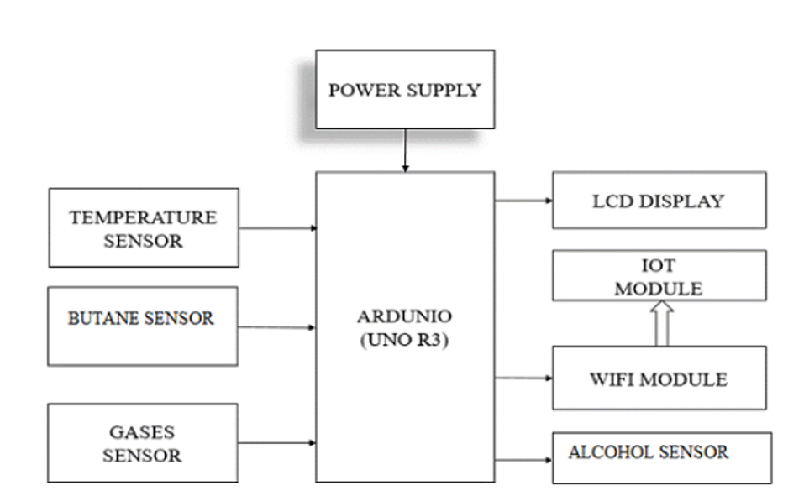

**Fig 2.1:** Block Diagram of Harmful gas detection and monitoring system In industries using IOT

**16X2 CD**

* 1. **HARDWARE USED**

**MQ2 Sensor**

MQ2 gas sensor is an electronic sensor used for sensing the concentration of gases in the air such as LPG, propane, methane, hydrogen, alcohol, smoke and carbon monoxide.MQ2 gas sensor is also known as chemiresistor. It contains a sensing material whose resistance changes when it comes in contact with the gas. This change in the value of resistance is used for the detection of gas.

**MQ7 Sensor**

This is a Carbon Monoxide (CO) sensor which can be easily utilized, appropriate in detecting cabon particles gas radiation noticeable focusing all around. This MQ-7 sensor has a range of 20 to 2000 PPM for detecting carbon particles gas radiation .This sensor is having high affectability with quick reaction time.

**MQ135**

MQ135 gas sensor has high sensitivity to Ammonia, Sulfide and Benzene steam, also sensitive to smoke and other harmful gases. Sensor SnO2 has the lower conductivity in the clear air which is used by Mq135 gas sensor as gas sensing material. The conductivity of this gas sensor increases as the concentration of gas that polluting the atmosphere increases.

**Wi-Fi Module**

ESP8266-Based Serial Wi-Fi Shield for Arduino is planned and created by Shenzhen Doctors of Intelligence &Technology (SZDOIT). At long last Cloud Server will apply information mining on informational indexes. It likewise mail or SMS Technician and send points of interest to the Owner (mail or SMS). We can interface any number of clients on cloud server so it underpins multi client framework attributes. Here we can utilize just a single cloud server yet we can associate many quantities of users to it by means of pc, or any android gadgets.

**LCD Display**

The LCD (Liquid Color Displays) for Arduino gives a straightforward correspondence between the client and the electronic framework in a simple and justifiable dialect. For any microcontroller, perusing and composing the characters to the LCD is the need errand, and among of microcontrollers, Arduino is the best. Arduino is an extraordinary stage for prototyping to interface the LCD shows, actuators, sensors, and so forth. Contingent upon your necessities and prerequisites.

**Power Supply**

6 to 20 volts power supply should be given to turn on the board. On the off chance that provided with under 7V, in any case, a 5volts stick will supply under with five volts and the board might be unsteady. On the off chance of utilizing more than that of 12V, the voltage controller unit may get overheated and can harm the board. The range prescribed is 7 to 12 volts. I've discovered that utilizing 9V functions admirably. You can essentially interface the + end of your battery to Arduino VIN and the conclusion to Arduino ground.

**Arduino UNO**

Arduino UNO is a microcontroller board based on the ATmega328P. The Arduino Uno R3 pin diagram is shown below. It comprises 14-digit I/O pins. From these pins, 6-pins can be utilized like PWM outputs. This board includes 14 digital input/output pins, Analog inputs-6, a USB connection, quartz crystal-16 MHz, a power jack, a USB connection, resonator 16Mhz, a power jack, an ICSP header an RST button.

* 1. **SOFTWARE USED**

**Arduino IDE Software**

The Arduino Integrated Development Environment (or) Arduino Software (IDE) contains a text editor for writing code, a message area, a text console, a toolbar with buttons for common functions and a series of menus. It connects to the Arduino hardware to upload programs and communicate with them. By using this software and Embedded C program we debugged the program to the Arduino UNO. The Arduino Software (IDE) uses the concept of a sketchbook: a standard place to store your programs (or sketches). The sketches in your sketchbook can be opened from the File > Sketchbook menu or from the Open button on the toolbar. The first time you run the Arduino software, it will automatically create a directory for your sketchbook. You can view or change the location of the sketchbook location from with the Preferences dialog.

**Thingspeak Software**

ThingSpeak is an IOT analytics platform service that allows you to aggregate, visualize and analyze live data streams in the cloud. ThingSpeak provides instant visualizations of data posted by your devices to ThingSpeak. Features of ThingSpeak include real-time data collection, data processing, visualizations, apps, and plugins. At the heart of ThingSpeak is a ThingSpeak Channel. A channel is where you send your data to be stored. Each channel includes 8 fields for any type of data, 3 location fields, and 1 status field. We Used Thingspeak software to store the Sensed values.

* 1. **ALGORITHM**

Step 1: Initialization.

Step 2: Connect power supply. S

tep 3: Sensors will sense the gas levels.

Step 4: Sensed value is updated to Arduino.

Step 5: Where it checks the sensed gas levels are Normal or Abnormal.

Step 6: If the sensed gas levels are more than fixed threshold value then it make buzzer sound.

Step 7: The gas levels are stored in cloud through the Wifi & IOT module.

Step 8: When we need to see the past gas levels then we can visit Cloud platform and where we can get the values.

Step 9: Repeat the same process.

### The Arduino UNO is the main heart of this project. MQ2,MQ7,MQ135,LM35 , buzzer, ESP8266 Wifi module, 16x2 LCD display are connected to the arduino. Each gas sensor analog pins are connected to the arduino analog inputs. LM35 temperature sensor output pin is connected to the arduino. VCC and ground pins of all sensors are connected to the 5V & ground pins of arduino respectively. I2C module is connected between LCD display and arduino, I2C module converts the series input to the parallel output. Gas sensors and temperature sensor continuously sense the gas & temperature levels, if the sensed gas levels is normal then it will updated to the cloud by the use of IOT module. The sensed values are displays in LCD display. While the sensed gas levels are abnormal then the buzzer sounds, then it is updated in cloud. Like this the temperature is also sensed by sensor, if it abnormal then the buzzer sounds and the data stored in cloud for future use.

### LIMITATIONS OF THE SYSTEM

* **Reliability:** IoT sensors may not always provide accurate readings, leading to false alarms or undetected leaks.
* **Coverage:** IoT sensor networks may not cover all areas where toxic gases could be present, leaving blind spots in monitoring.
* **Cost:** Implementing IoT sensor networks can be expensive, especially for large or remote areas.
* **Maintenance:** Regular maintenance and calibration of IoT sensors are necessary to ensure their effectiveness, which adds to operational costs.
* **Data Security:** Transmitting sensitive data from IoT sensors over networks raises concerns about data privacy and security.
* **Response Time:** There may be delays in detecting and responding to toxic gas leaks due to communication latency or sensor malfunction.
* **Interference:** Environmental factors such as temperature, humidity, and electromagnetic interference can affect the accuracy of IoT sensor readings.
* **Integration**: Integrating IoT systems with existing infrastructure and emergency response protocols may pose challenges, requiring significant coordination and investment.
* **Power Consumption:** IoT devices require power to operate, which can be a challenge in remote locations or during power outages.

# CHAPTER-3

# PROPOSED METHOD

## CHAPTER-3

## PROPOSEDMETHOD

### MONITORINGTOXIC GASES USING NANOTECHNOLOGY AND WIRELESS SENSORS

Monitoring toxic gases using nanotechnology and wireless sensors represents a cutting-edge approach to ensuring environmental safety and public health. Nanotechnology enables the fabrication of highly sensitive gas sensors at the nanoscale level, allowing for the detection of even trace amounts of toxic gases with remarkable accuracy. These sensors are often composed of nanomaterials such as carbon nanotubes or metal oxides, which exhibit unique properties that make them ideal for gas sensing applications. By integrating these nanomaterial-based sensors into wireless networks, real-time monitoring of toxic gases becomes feasible over large areas, enabling early detection of potential hazards. Furthermore, the wireless connectivity enables remote data collection and analysis, providing timely alerts and facilitating rapid response measures in case of gas leaks or environmental contamination incidents. This amalgamation of nanotechnology and wireless sensors not only enhances the efficiency and reliability of toxic gas monitoring but also contributes to overall environmental sustainability and safety standards.

### OBJECTIVE

The main objective is to ensure early detection and continuous surveillance of toxic gases, leveraging nanotechnology for precision and wireless sensors for real-time monitoring, aiming to prevent harm to human health and the environment.

* 1. **LOCK DIAGRAM OF PROPOSEDSYSTEM**

**Micro**

**controller**

**16X2 LCD**

**POWER**

**SUPPLY**

**BUZZER**

**MQ2**

**SENSOR**

**MQ135 SENSOR**

**GSM MODULE**

**DHT11 SENSOR**

**Fig-3.1:**Block Diagram of Proposed System

This is a simple block diagram that explains the monitoring toxic gases using nanotechnology and wireless sensors using Arduino UNO, Power supply, 16*2 LCD Display ,GSM Module,MQ2 Sensor ,MQ135 sensor,DHT11 sensor. The Arduino processes the code and displays it to 16*2 LCD Display.

### ARDUINO

## The Arduino Uno is an open-source microcontroller board based on the Microchip ATmega328P microcontroller and developed by Arduino.cc. The board is equipped with sets of digital and analog input/output (I/O) pins that may be interfaced to various expansion boards (shields) and other circuits. The board has 14 digital I/O pins (six capable of PWM output), 6 analog I/O pins, and is programmable with the Arduino IDE (Integrated Development Environment), via a type B USB cable. It can be powered by the USB cable or by an external 9-volt battery, though it accepts voltages between 7 and 20 volts. It is also similar to the Arduino Nano and Leonardo. The hardware reference design is distributed under a Creative Commons Attribution Share-Alike 2.5 license and is available on the Arduino website. Layout and production files for some versions of the hardware are also available.

## Arduino Uno - WikipediaThe word "uno" means "one" in Italian and was chosen to mark the initial release of Arduino Software. The Uno board is the first in a series of USB-based Arduino boards;[3] it and version 1.0 of the Arduino IDE were the reference versions of Arduino, which have now evolved to newer releases. The ATmega328 on the board comes preprogrammed with a bootloader that allows uploading new code to it without the use of an external hardware programmer.

**Fig-3.2:**ArduinoUNO

### FEATURES OF ARDUINO UNO

The features of Arduino Uno ATmega328 includes the following:

* The operating voltage is 5V
* The recommended input voltage will range from 7v to 12V
* The input voltage ranges from 6v to 20V
* Digital input/output pins are 14
* Analog i/p pins are 6
* DC Current for each input/output pin is 40 mA
* DC Current for 3.3V Pin is 50 mA
* Flash Memory is 32 KB
* SRAM is 2 KB
* EEPROM is 1 KB
* CLK Speed is 16 MHz
* It is an easy USB interface.
* It has a 32 KB of flash memory for storing your code.
* It is an easy USB interface. This allows interface with USB as this is like a serial device.
* It is an easy USB interface. This allows interface with USB as this is like a serial device.
* An on-board LED is attached to digital pin 13 to make fast the debugging of code and to make the debug process easy.
* The chip on the board plugs straight into your USB port and supports on your computer as a virtual serial port.
* It is an open-source design and there is an advantage of being open source is that it has a large community of people using and troubleshooting it.

### ARDUINO UNO PIN DESCRIPTION

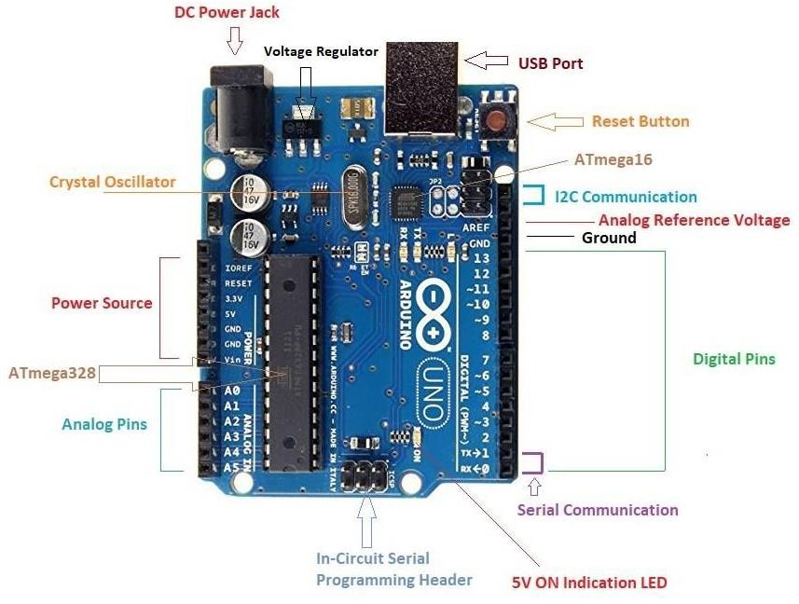

**Fig-3.3:** Pinout of Arduino UNO

The Arduino Uno board can be built with power pins, analog pins, ATmegs328, ICSP header, Reset button, [power LED,](https://www.elprocus.com/solar-powered-led-street-light-control-circuit/) digital pins, test led 13, TX/RX pins, USB interface, an external [power supply.](https://www.elprocus.com/difference-between-single-phase-and-three-phase-ac-power-supply/)

* + - * **Power Supply**: The Arduino Uno power supply can be done with the help of a USB cable or an external power supply. The external power supplies mainly include AC to DC adapter otherwise a battery. The adapter can be connected to the Arduino Uno by plugging into the power jack of the Arduino board. Similarly, [**the battery**](https://www.elprocus.com/an-overview-of-bio-battery-working-principle-types-applications/) leads can be connected to the Vin pin and the GND pin of the POWER connector. The suggested voltage range will be 7 volts to 12 volts.
      * **Input & Output:** The 14 digital pins on the Arduino Uno can be used as input & output with the help of the functions like pinMode(), digitalWrite() & digitalRead().
      * **Pin1 (TX) & Pin0 (RX) (Serial):** This pin is used to transmit & receive TTL serial data, and these are connected to the ATmega8U2 USB to TTL Serial chip equivalent pins.
      * **Pin 2 & Pin 3 (External Interrupts):** External pins can be connected to activate an interrupt over a low value, change in value.
      * **Pins 3, 5, 6, 9, 10, & 11 (PWM):** This pin gives 8-bit PWM o/p by the function of analogWrite().
      * **SPI Pins (Pin-10 (SS), Pin-11 (MOSI), Pin-12 (MISO), Pin-13 (SCK):** These pins maintain SPI-communication, even though offered by the fundamental hardware, is not presently included within the Arduino language.
      * **Pin-13(LED):** The inbuilt LED can be connected to pin-13 (digital pin). As the HIGH- value pin, the light emitting diode is activated, whenever the pin is LOW.
      * **Pin-4 (SDA) & Pin-5 (SCL) (I2C):** It supports TWI-communication with the help of the Wire library.
      * **AREF (Reference Voltage):** The reference voltage is for the analog i/ps with analogReference().
      * **Reset Pin:** This pin is used for reset (RST) the microcontroller.
      * **Memory**: The memory of this Atmega328 Arduino microcontroller includes flash memory-32 KB for storing code, SRAM-2 KB EEPROM-1 KB.
      * **Communication:**

The Arduino Uno ATmega328 offers UART TTL-[serial communication](https://www.elprocus.com/i2c-bus-protocol-tutorial-interface-applications/), and it is accessible on digital pins like TX (1) and RX (0). The software of an Arduino has a serial monitor that permits easy data. There are two LEDs on the board like RX & TX which will blink whenever data is being broadcasted through the USB.A SoftwareSerial library permits for serial communication on Arduino Uno digital pins and the ATmega328P supports TWI (I2C) as well as [**SPI-communication**](https://www.elprocus.com/serial-peripheral-interface-spi-communication-protocol/).

### ADVANTAGES OF ARDUINO

There are many other microcontrollers and microcontroller platforms available for physical

Computing. Parallax Basic Stamp, Netmedia's BX-24, Phidgets, MIT's Handyboard and many others offer similar functionality. All of these tools take the messy details of microcontroller programming and wrap it up in an easy-to-use package. Arduino also simplifies the process of working with microcontrollers, but it offers some advantage for teachers, students, and interested amateurs over other systems as follows:

* + - * **Inexpensive** - Arduino boards are relatively inexpensive compared to other microcontroller platforms. The least expensive version of the Arduino module can be assembled by hand, and even the pre-assembled Arduino modules cost less than \$50
      * **Cross-platform** - The Arduino Software (IDE) runs on Windows, Macintosh OSX, and Linux operating systems. Most microcontroller systems are limited to Windows.
      * **Simple, clear programming environment** - The Arduino Software (IDE) is easy-to- use for beginners, yet flexible enough for advanced users to take advantage of as well. For teachers, it's conveniently based on the Processing programming environment, so students learning to program in that environment will be familiar with how the Arduino IDE works.
      * **Open source and extensible software** - The Arduino software is published as open- source tools, available for extension by experienced programmers. The language can be expanded through C++ libraries, and people wanting to understand the technical details can make the leap from Arduino to the AVR C programming language on which it's based. Similarly, you can add AVR-C code directly into your Arduino programs if you want to.
      * **Open source and extensible hardware** - The plans of the Arduino boards are published under a Creative Commons license, so experienced circuit designers can make their own version of the module, extending it and improving it. Even relatively inexperienced users can build the [breadboard version of the module](https://www.arduino.cc/en/Main/Standalone) in order to understand how it works and save money.

The **Arduino Uno** is one kind of microcontroller board based on ATmega328, and Uno is an Italian term which means one. Arduino Uno is named for marking the upcoming release of microcontroller board namely **Arduino Uno Board 1.0**. This board includes digital I/O pins-14, a power jack, analog inputs-6, ceramic resonator-16 MHz, a USB connection, an RST button, and an ICSP header. All these can support the microcontroller for further operation by connecting this board to the computer. The power supply of this board can be done with the help of an AC to DC adapter, a USB cable, otherwise a battery.

The ATmega328 is one kind of single-chip microcontroller formed with Atmel within the mega AVR family**.** The architecture of this Arduino Uno is a customized Harvard architecture with 8 bit [RISC processor](https://www.elprocus.com/difference-between-risc-and-cisc-architecture/) core. [Other boards of Arduino](https://www.elprocus.com/different-types-of-arduino-boards/) Uno include Arduino Pro Mini, Arduino Nano, Arduino Due, Arduino Mega, and Arduino Leonardo.

.

### HOW TO USE ARDUINO

Arduino Uno can detect the surroundings from the input. Here the input is a variety of sensors and these can affect its surroundings through controlling motors, lights, other actuators, etc. The ATmega328 microcontroller on the Arduino board can be programmed with the help of an Arduino programming language and the IDE(Integrated Development Environment). [**Arduino projects**](https://www.elprocus.com/arduino-boards-electronics-and-electrical-engineering-projects/) can communicate by software while running on a PC.

### ARDUINO PROGRAMMING

Once the Arduino IDE tool is installed in the PC, attach the Arduino board to the computer with the help of USB cable. Open the Arduino IDE & select the right board by choosing Tools–>Board>Arduino Uno, and select the right Port by choosing Tools–>Port. This board can be programmed with the help of an Arduino [**programming language**](https://www.elprocus.com/8051-assembly-language-programming/) depends on Wiring.

To activate the Arduino board & [flash the LED](https://www.elprocus.com/blinking-led-using-555-timer-ic/) on the board, dump the program code with the selection of Files–> Examples>Basics>Flash. When the programming codes are dumped into the IDE, and then click the button ‘upload’ on the top bar. Once this process is completed, check the LED flash on the board.

### HIGH VOLTAGE PROTECTION OF USB

The Arduino Uno board has a rearrangeable poly fuse that defends the USB port of the PC from the over-voltage. Though most of the PCs have their own inner protection, the fuse gives an additional coating of safety. If above 500mA is given to the USB port, then the fuse will routinely crack the connection until the over-voltage is removed.

### APPLICATIONS OF ARDUINO UNO

* + - * Weighing Machines
      * Traffic Light Count Down Timer
      * Parking IoT Counter
      * Embedded systems
      * Home Automation and Industrial Automation
      * Medical Instrument
      * Emergency Light for Railways

### MICROCONTROLLER

A microcontroller is a small and low-cost microcomputer, which is designed to perform the specific tasks of embedded systems like displaying microwave’s information, receiving remote signals, etc. The general microcontroller consists of the processor, the memory (RAM, ROM, EPROM), Serial ports, Peripherals (timers, counters.), etc. A microcontroller (MCU for microcontroller unit) is a small computer on a single VLSI integrated circuit (IC) chip. A microcontroller contains one or more [CPUs](https://en.wikipedia.org/wiki/Central_processing_unit) ([processor cores](https://en.wikipedia.org/wiki/Processor_core)) along with [memory](https://en.wikipedia.org/wiki/Computer_memory) and programmable [input/output](https://en.wikipedia.org/wiki/Input/output) peripherals. Program memory in the form of [ferroelectric](https://en.wikipedia.org/wiki/Ferroelectric_RAM) [RAM](https://en.wikipedia.org/wiki/Ferroelectric_RAM), [NOR flash](https://en.wikipedia.org/wiki/Flash_memory#NOR_flash) or [OTPROM](https://en.wikipedia.org/wiki/Programmable_read-only_memory) is also often included on chip, as well as a small amount of [RAM](https://en.wikipedia.org/wiki/Random-access_memory).

Microcontrollers are designed for [embedded](https://en.wikipedia.org/wiki/Embedded_system) applications, in contrast to the [microprocessors](https://en.wikipedia.org/wiki/Microprocessor) used in [personal computers](https://en.wikipedia.org/wiki/Personal_computer) or other general purpose applications consisting of various discrete chips. In modern terminology, a microcontroller is similar to, but less

sophisticated than, a [system on a chip](https://en.wikipedia.org/wiki/System_on_a_chip) (SoC). An SoC may connect the external microcontroller chips as the motherboard components, but an SoC usually integrates the advanced peripherals like [graphics processing unit](https://en.wikipedia.org/wiki/Graphics_processing_unit) (GPU) and [Wi-Fi](https://en.wikipedia.org/wiki/Wi-Fi) interface controller as its internal microcontroller unit circuits.

Microcontrollers are used in [automatically controlled](https://en.wikipedia.org/wiki/Control_system) products and devices, such as automobile engine control systems, implant a biomedical devices, remote controls, office machines, appliances, power tools, toys and other [embedded systems](https://en.wikipedia.org/wiki/Embedded_system). By reducing the size and cost compared to a design that uses a separate [microprocessor](https://en.wikipedia.org/wiki/Microprocessor), memory, and input/output devices, microcontrollers make it economical to digitally control even more devices and processes.

[Mixed signal](https://en.wikipedia.org/wiki/Mixed-signal_integrated_circuit) microcontrollers are common, integrating analog components needed to control non-digital electronic systems. In the context of the [internet of things](https://en.wikipedia.org/wiki/Internet_of_things), microcontrollers are an economical and popular means of [data collection,](https://en.wikipedia.org/wiki/Data_collection) [sensing](https://en.wikipedia.org/wiki/Sensor) and [actuating](https://en.wikipedia.org/wiki/Actuator) the physical world as [edge devices.](https://en.wikipedia.org/wiki/Edge_device) Some microcontrollers may use four-bit [words](https://en.wikipedia.org/wiki/Word_(computer_architecture)) and operate at frequencies as low as4 kHz for low [power consumption](https://en.wikipedia.org/wiki/Electric_energy_consumption) (single-digit [milliwatts](https://en.wikipedia.org/wiki/Watt) or microwatts).

They generally have the ability to retain functionality while [waiting](https://en.wikipedia.org/wiki/Wait_state) for an [event](https://en.wikipedia.org/wiki/Event-driven_architecture) such as a button press or other [interrupt](https://en.wikipedia.org/wiki/Interrupt);powerconsumptionwhilesleeping(CPUclockandmostperipherals off) may be just nanowatts, making many of them well suited for long lasting battery applications. Other microcontrollers may serve performance-critical roles, where they may need to act more like a [digital signal processor](https://en.wikipedia.org/wiki/Digital_signal_processor) (DSP),with higher clock speeds and power consumption.

The 8051 microcontroller was invented in 1980's by Intel. Its foundation is based on Harvard architecture and this microcontroller was developed principally for bringing it to be used in **Embedded Systems**. At first it was created by using NMOS technology but the use of NMOS consumed more power to work therefore Intel re-launch the microcontroller 8051 using CMOS technology and new edition came up with edition of letter 'C' in the title name, therefore the new modified version of microcontroller is called by name 80C51.

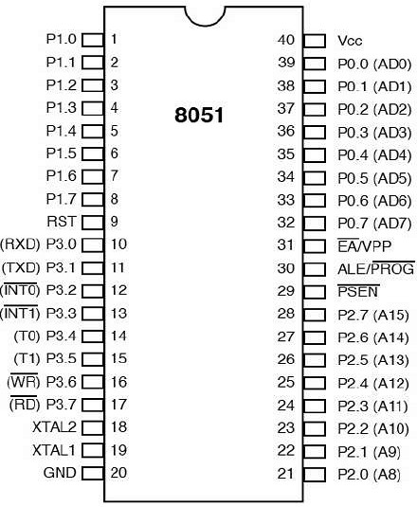**3.5.1 INPUT & OUTPUT PORTS:**

## Fig-3.4 Input & output ports of 8051

## The 14 digital pins on the Arduino Uno can be used as input & output with the help of the functions like pin Mode (), digital Write (), & Digital Read()

## **Pin1 (TX) & Pin0 (RX) (Serial):** This pin is used to transmit & receive TTL serial data, and these are connected to the ATmega8U2 USB to TTL Serial chip equivalent pins.

## **Pin 2 & Pin 3 (External Interrupts):** External pins can be connected to activate an interrupt over a low value, change in value.

## **Pins 4, 5, 6, 9, 10, & 11 (PWM):** This pin gives 8-bit PWM o/p by the function of analog Write ().

## **SPI Pins (Pin-10 (SS), Pin-11 (MOSI), Pin-12 (MISO), Pin-13 (SCK):** These pins maintain SPI - communication, even though offered by the fundamental hardware, is not presently included within the Arduino language.

**Pin-13(LED):** The inbuilt LED can be connected to pin-13 (digital pin). As the HIGH-value pin, the light emitting diode is activated, whenever the pin is LOW.

**Pin-4 (SDA) & Pin-5 (SCL) (I2C):** It supports TWI-communication with the help of the Wire library.

**AREF (Reference Voltage):** The reference voltage is for the analogi/ps with analog Reference ().

**Reset Pin:** This pin is used for reset (RST) the microcontroller.

**Memory**: The memory of this Atmega328 Arduino microcontroller includes flash memory-32 KB for storing code, SRAM-2 KB EEPROM-1 KB. **Communication** The Arduino Uno ATmega328 offers UART TTL-[**serial communication**](https://www.elprocus.com/i2c-bus-protocol-tutorial-interface-applications/), and it is accessible on digital pins like TX (1) and RX (0). The software of an Arduino has a serial monitor that permits easy data. There are two LEDs on the board like RX & TX which will blink whenever data is being broadcasted through the USB.A Software Serial library permits for serial communication on Arduino Uno digital pins and the ATmega328P supports TWI (I2C) as well as [**SPI-communication**](https://www.elprocus.com/serial-peripheral-interface-spi-communication-protocol/). The Arduino software contains a wired library for simplifying the utilization of the I2C bus.

### 3.5.2 APPLICATIONS OF MICROCONTROLLER

Microcontrollers are widely used in various different devices such as −

* + - * + Light sensing and controlling devices like LED.
        + Temperature sensing and controlling devices like microwave oven, chimneys.
        + Fire detection and safety devices like Fire alarm.
        + Measuring devices like Volt Meter.
  1. **MQ135 Sensor**

The MQ-135 Gas sensor can detect gases like Ammonia (NH3), sulfur (S), Benzene (C6H6), CO2, and other harmful gases and smoke. Similar to other MQ series gas sensor, this sensor also has a digital and analog output pin. When the level of these gases go beyond a threshold limit in the air the digital pin goes high. This threshold value can be set by using the on-board potentiometer. The analog output pin, outputs an analog voltage which can be used to approximate the level of these gases in the atmosphere.

The gas sensor module consists of a steel exoskeleton under which a sensing element is housed. This sensing element is subjected to current through connecting leads. This current is known as heating current through it, the gases coming close to the sensing element get ionized and are absorbed by the sensing element.

The MQ135 air quality sensor module operates at 5V and consumes around 150mA. It requires some preheating before it could actually give accurate results. This changes the resistance of the sensing element which alters the value of the current going out of it.

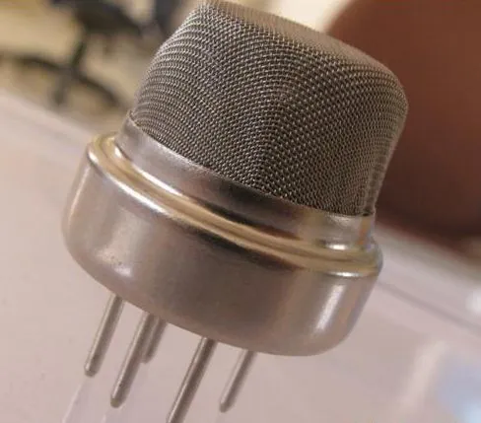

**3.6.1 Details of MQ135 Sensor:**

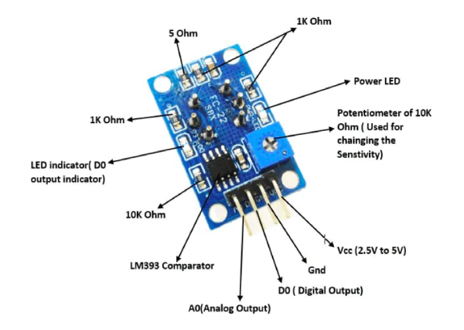The MQ135 is one of the popular gas sensors from the MQ series of sensors that are commonly used in air quality control equipment.

**Fig:3.6 Details of MQ135 Sensor**

It operates from 2.5V to 5.0V and can provide both digital and analog output. The pinouts and important components on an MQ135 Module is marked below

Note that all MQ sensors have to be powered up for a pre-heat duration for the sensor to warm up before it can start working. This preheat time is normally between 30 seconds to a couple of minutes. When you power up the module the power LED will turn on, leave the module in this state till the pre-heat duration is completed.

The digital output pin of the sensor can be used to detect harmful gases in the environment. The sensitivity of the digital pin can be controlled by using the 10k potentiometer. If the gas is detected the indicator LED D0 will turn on and the digital pin will go from logic high to logic low (0V). The LM393 Op-Amp Comparator IC is used to compare the actual gas value with the value set using the potentiometer. If the actual gas value increases than the set value then the digital output pin gets low.

Because of the onboard LM393 comparator IC the MQ135 Gas sensor module can also be used without the need of an external microcontroller. Simply power up the module and set the sensitivity of the digital pin using the potentiometer, then when the module detects the gas the digital pin will go low. This digital pin can directly be used to drive a buzzer or LED with the help of simple transistors.

**3.6.2 Pin Configuration MQ-135 gas sensor:**

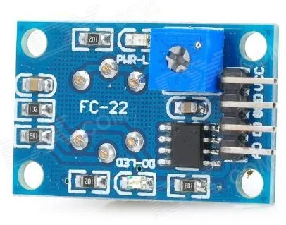From left to right first pins are as follows:

**Fig: 3.6Pin Configuration MQ-135 gas sensor**

* A0 Analog output
* D0 Digital output
* GND Ground
* Vcc Supply (5V)

**3.6.3 Specifications of MQ-135 gas sensor:**

* Wide detecting scope
* Fast response and High sensitivity
* Stable and long-life Simple drive circuit
* Used in air quality control equipment for buildings/offices, is suitable for detecting of NH3, NOx, alcohol, Benzene, smoke, CO2, etc.
* Size: 35mm x 22mm x 23mm (length x width x height)
* Working voltage: DC 5 V
* Signal output instruction.
* Dual signal output (analog output, and high/low digital output)
* 0 ~ 4.2V analog output voltage, the higher the concentration the higher the voltage.

**3.6.4 Measure PPM Value using Analog Pin:**

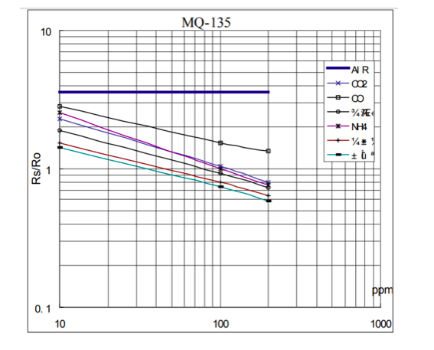The Analog output pin of the sensor can be used to measure the PPM value of the required gas. To do this we need to use an external microcontroller like Arduino.

**Fig: 3.7 Measure PPM Value using Analog Pin**

The microcontroller will measure the value of analog voltage and perform some calculations to find the value of Rs/Ro where Rs is the sensor resistance when gas is present and Ro is sensor resistance at clean air. Once we find this ratio of Rs/Ro we can use it to calculate the PPM value of required gas using the graph below which is taken from the datasheet of MQ135 Sensor. If you are just detecting the gas and not measuring the PPM then the module need not be calibrated or pre-heated and hence it is extremely simple to use. You can find these MQ Gas sensors commonly used in Gas/Smoke detectors and Air Quality Monitors.

## 3.7 MQ2 Gas Sensor

The MQ2 sensor is one of the most widely used in the MQ sensor series. It is a MOS (Metal Oxide Semiconductor) sensor. Metal oxide sensors are also known as **Chemiresistors**because sensing is based on the change in resistance of the sensing material 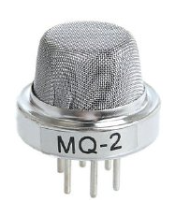

The MQ2 gas sensor operates on 5V DC and consumes approximately 800mW. It can detect **LPG**, **Smoke**, **Alcohol**, **Propane**, **Hydrogen**, **Methane** and **Carbon Monoxide** concentrations ranging from 200 to 10000 ppm. Note that the MQ2 gas sensor detects multiple gases, but cannot identify them! That is normal; most gas sensors operate in this manner. Therefore, it is best suited for measuring changes in a known gas density rather than detecting which one is changing.

**Fig: 3.8 Mq2 gas sensor**

## Internal structure of MQ2 Gas Sensor

The MQ2 is a heater-driven sensor. It is therefore covered with two layers of fine stainless steel mesh known as an “anti-explosion network”. It ensures that the heater element inside the sensor does not cause an explosion because we are sensing flammable gasses.

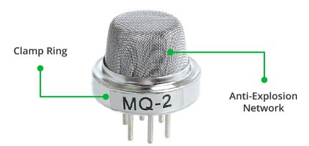

It also protects the sensor and filters out suspended particles, allowing only gaseous elements to pass through the chamber. A copper-plated clamping ring secures the mesh to the rest of the body.

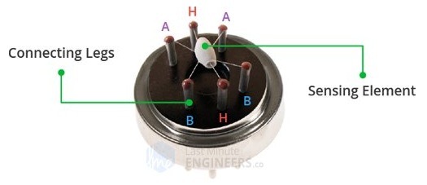

**Fig: 3.9 Internal structure of gas sensor**

When the outer mesh is removed, the sensor looks like this. The sensing element and six connecting legs that extend beyond the Bakelite base form the star-shaped structure. Two (H) of the six leads are in charge of heating the sensing element and are linked together by a Nickel-Chromium coil (a well-known conductive alloy).

The remaining four signal-carrying leads (A and B) are connected with platinum wires. These wires are connected to the body of the sensing element and convey slight variations in the current flowing through the sensing element.

When the outer mesh is removed, the sensor looks like this. The sensing element and six connecting legs that extend beyond the Bakelite base form the star-shaped structure. Two (H) of the six leads are in charge of heating the sensing element and are linked together by a Nickel-Chromium coil (a well-known conductive alloy).

The remaining four signal-carrying leads (A and B) are connected with platinum wires. These wires are connected to the body of the sensing element and convey slight variations in the current flowing through the sensing element.

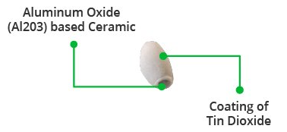

**Fig: 3.10 Tubular sensing element**

The tubular sensing element is made of Aluminium Oxide (AL2O3) based ceramic with a Tin Dioxide coating (SnO2). Tin Dioxide is the most important material because it is sensitive to combustible gasses. The ceramic substrate, on the other hand, improves heating efficiency and ensures that the sensor area is continuously heated to the working temperature.

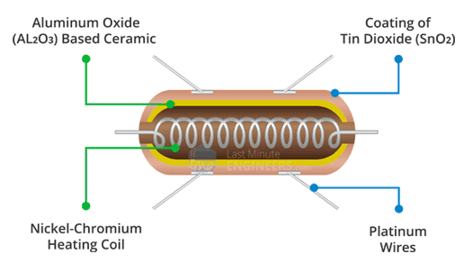

To summarize, the Heating System is composed of a Nickel-Chromium coil and an Aluminum Oxide-based ceramic, while the Sensing System is composed of Platinum wires and a Tin Dioxide coating.

## How Does a Gas Sensor Work?

When a SnO2 semiconductor layer is heated to a high temperature, oxygen is adsorbed on the surface. When the air is clean, electrons from the conduction band of tin dioxide are attracted to oxygen molecules. This creates an electron depletion layer just beneath the surface of the SnO2 particles, forming a potential barrier. As a result, the SnO2 film becomes highly resistive and prevents electric current flow.

The MQ2 gas sensor is simple to use and has two different outputs. It not only provides a binary indication of the presence of combustible gasses, but also an analog representation of their concentration in air.

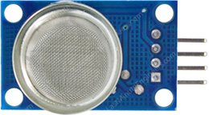

The sensor’s analog output voltage (at the A0 pin) varies in proportion to the concentration of smoke/gas. The higher the concentration, the higher the output voltage; the lower the concentration, the lower the output voltage. The animation below shows the relationship between gas concentration and output voltage.

Ezoic



This analog signal is digitized by an LM393 High Precision Comparator and made available at the Digital Output (D0) pin.

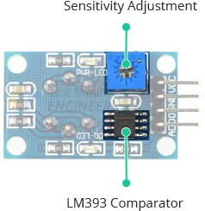

The module includes a potentiometer for adjusting the sensitivity of the digital output (D0). You can use it to set a threshold so that when the gas concentration exceeds the threshold value, the module outputs LOW otherwise HIGH.

Rotating the knob clockwise increases sensitivity and counterclockwise decreases it.

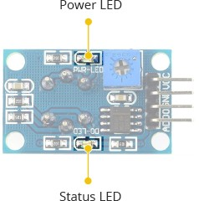

In addition, the module has two LEDs. The Power LED illuminates when the module is turned on, and the Status LED illuminates when the gas concentration exceeds the threshold value.

### Technical Specifications

Here are the specifications:

|  |  |
| --- | --- |
| Operating voltage | 5V |
| Load resistance | 20 KΩ |
| Heater resistance | 33Ω ± 5% |
| Heating consumption | <800mw |
| Sensing Resistance | 10 KΩ – 60 KΩ |
| Concentration Range | 200 – 10000ppm |
| Preheat Time | Over 24 hour |

## MQ2 Gas Sensor Module Pinout

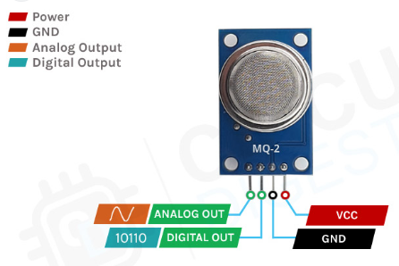

VCC supplies power to the module. Connect it to the 5V output of your Arduino.

GND is the ground pin.

D0 indicates the presence of combustible gasses. D0 becomes LOW when the gas concentration exceeds the threshold value (as set by the potentiometer), and HIGH otherwise.

A0 produces an analog output voltage proportional to gas concentration, so a higher concentration result in a higher voltage and a lower concentration result in a lower voltage

**3.8 DHT11 Sensor:**

The DHT11 is a basic, ultralow-cost digital temperature and humidity sensor. It uses a capacitive humidity sensor and a thermistor to measure the surrounding air and spits out a digital signal on the data pin (no analog input pins needed). It's fairly simple to use but requires careful timing to grab data. The only real downside of this sensor is you can only get new data from it once every 2 seconds, so when using our library, sensor readings can be up to 2 seconds old.

The calibration coefficients are stored as programmes in the OTP memory, which are used by the sensor’s internal signal detecting process. The single-wire serial interface makes system integration quick and easy. Its small size, low power consumption and up-to-20meter signal transmission make it the best choice for various applications, including those most demanding ones. The component is a 4-pin single row pin package. It is convenient to connect and special packages can be provided according to users’ request.

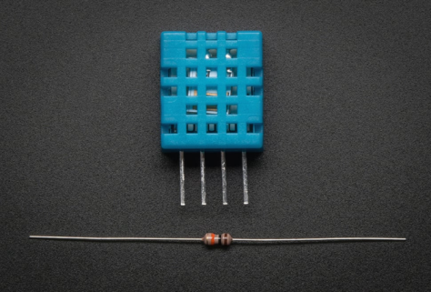

**Fig: 3.8 DHT11 Sensor**

**3.8.1 Technical Specifications:**

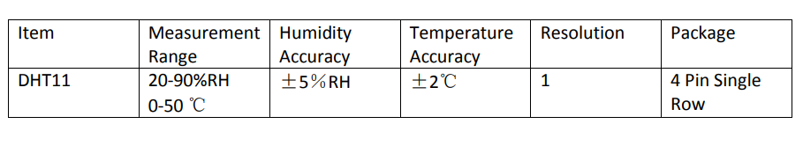**Overview:**

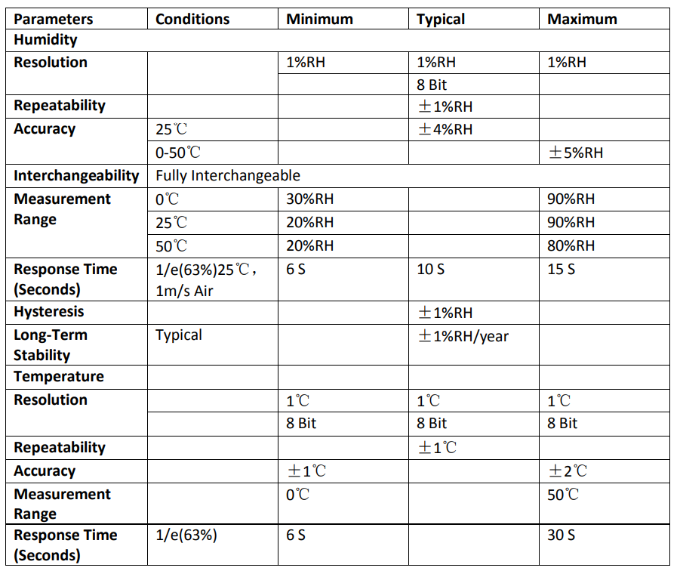

**Fig: 3.9Technical Specifications**

* Low cost
* 3 to 5V power and I/O
* 2.5mA max current use during conversion (while requesting data)
* Good for 20-80% humidity readings with 5% accuracy
* Good for 0-50°C temperature readings ±2°C accuracy
* No more than 1 Hz sampling rate (once every second)
* Body size 15.5mm x 12mm x 5.5mm
* 4 pins with 0.1" spacing.

**3.9 Alphanumeric LCD**

Liquid Crystal Display also called as LCD is very helpful in providing user interface as well as for debugging purpose. The most commonly used Character based LCDs are based on Hitachi's HD44780 controller or other which are compatible with HD44580. The most commonly used LCDs found in the market today are 1 Line, 2 Line or 4 Line LCDs which have only 1 controller and support at most of 80 characters, whereas LCDs supporting more than 80 characters make use of 2 HD44780 controllers.

**Pin Description**

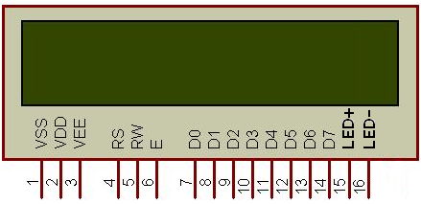

|  |  |  |
| --- | --- | --- |
| **Pin No.** | **Name** | **Description** |
| 1 | **VSS** | Power supply (GND) |
| 2 | **VCC** | Power supply (+5V) |
| 3 | **VEE** | Contrast adjust |
| 4 | **RS** | 0 = Instruction input 1 = Data input |
| 5 | **R/W** | 0 = Write to LCD module 1 = Read from LCD module |
| 6 | **EN** | Enable signal |
| 7 | **D0** | Data bus line 0 (LSB) |
| 8 | **D1** | Data bus line 1 |
| 9 | **D2** | Data bus line 2 |
| 10 | **D3** | Data bus line 3 |
| 11 | **D4** | Data bus line 4 |
| 12 | **D5** | Data bus line 5 |
| 13 | **D6** | Data bus line 6 |
| 14 | **D7** | Data bus line 7 (MSB) |
| 15 | **LED+** | Back Light VCC |
| 16 | **LED-** | Back Light GND |

**DDRAM - Display Data RAM**

Displaydata RAM (DDRAM) stores display data represented in 8-bit character codes. Its extended capacity is 80 X 8 bits, or 80 characters. The area in display data RAM (DDRAM) that is not used for display can be used as general data RAM. So whatever you send on the DDRAM is actually displayed on the LCD. For LCDs like 1x16, only 16 characters are visible, so whatever you write after 16 chars is written in DDRAM but is not visible to the user.

**CGROM - Character Generator ROM**

Now you might be thinking that when you send an ASCII value to DDRAM, how the character is displayed on LCD? So, the answer is CGROM. The character generator ROM generates 5 x 8 dot or 5 x 10 dot character patterns from 8-bit character codes. It can generate 208 5 x 8 dot character patterns and 32 5 x 10 dot character patterns.

**CGRAM - Character Generator RAM**

As clear from the name, CGRAM area is used to create custom characters in LCD. In the character generator RAM, the user can rewrite character patterns by program. For 5 x 8 dots, eight-character patterns can be written, and for 5 x 10 dots, four-character patterns can be written.

**BF - Busy Flag**

Busy Flag is a status indicator flag for LCD. When we send a command or data to the LCD for processing, this flag is set (i.e. BF =1) and as soon as the instruction is executed successfully this flag is cleared (BF = 0). This is helpful in producing and exact amount of delay for the LCD processing.

To read Busy Flag, the condition RS = 0 and R/W = 1 must be met and The MSB of the LCD data bus (D7) act as busy flag. When BF = 1 means LCD is busy and will not accept next command or data and BF = 0 means LCD is ready for the next command or data to process.

**Instruction Register (IR) and Data Register (DR)**

There are two 8-bit registers in HD44780 controller Instruction and Data register. Instruction register corresponds to the register where you send commands to LCD e.g. LCD shift command, LCD clear, LCD address etc. and Data register is used for storing data which is to be displayed on LCD. When send the enable signal of the LCD is asserted, the data on the pins is latched in to the data register and data is then moved automatically to the DDRAM and hence is displayed on the LCD. Data Register is not only used for sending data to DDRAM but also for CGRAM, the address where you want to send the data, is decided by the instruction you send to LCD.

**Commands and Instruction set**

Only the instruction register (IR) and the data register (DR) of the LCD can be controlled by the MCU. Before starting the internal operation of the LCD, control information is temporarily stored into these registers to allow interfacing with various MCUs, which operate at different speeds, or various peripheral control devices. The internal operation of the LCD is determined by signals sent from the MCU. These signals, which include register selection signal (RS), read/write signal (R/W), and the data bus (DB0 to DB7), make up the LCD instructions (Table 3). There are four categories of instructions that:

* Designate LCD functions, such as display format, data length, etc.
* Set internal RAM addresses
* Perform data transfer with internal RAM

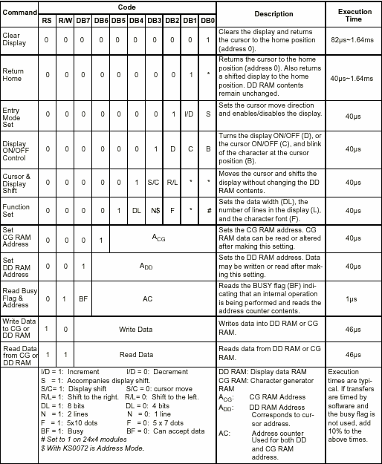

Although looking at the table you can make your own commands and test them. Below is a brief list of useful commands which are used frequently while working on the LCD.

|  |  |  |  |
| --- | --- | --- | --- |
| No. | Instruction | Hex | Decimal |
| 1 | Function Set: 8-bit, 1 Line, 5x7 Dots | 0x30 | 48 |
| 2 | Function Set: 8-bit, 2 Line, 5x7 Dots | 0x38 | 56 |
| 3 | Function Set: 4-bit, 1 Line, 5x7 Dots | 0x20 | 32 |
| 4 | Function Set: 4-bit, 2 Line, 5x7 Dots | 0x28 | 40 |
| 5 | Entry Mode | 0x06 | 6 |
| 6 | Display off Cursor off (clearing display without clearing DDRAM content) | 0x08 | 8 |
| 7 | Display on Cursor on | 0x0E | 14 |
| 8 | Display on Cursor off | 0x0C | 12 |
| 9 | Display on Cursor blinking | 0x0F | 15 |
| 10 | Shift entire display left | 0x18 | 24 |
| 12 | Shift entire display right | 0x1C | 30 |
| 13 | Move cursor left by one character | 0x10 | 16 |
| 14 | Move cursor right by one character | 0x14 | 20 |
| 15 | Clear Display (also clear DDRAM content) | 0x01 | 1 |
| 16 | Set DDRAM address or cursor position on display | 0x80+add | 128+add |
| 17 | Set CGRAM address or set pointer to CGRAM location | 0x40+add | 64+add |

**Sending Commands to LCD**

To send commands we simply need to select the command register. Everything is same as we have done in the initialization routine. But we will summarize the common steps and put them in a single subroutine. Following are the steps:

* move data to LCD port
* select command register
* select write operation
* send enable signal
* wait for LCD to process the command

**Sending Data to LCD**

To send data we simply need to select the data register. Everything is same as the command routine. Following are the steps:

* move data to LCD port
* select data register
* select write operation
* send enable signal
* wait for LCD to process the data

**3.10 GSM MODEM:**

GSM is a mobile communication modem; it is stands for global system for mobile communication (GSM). The idea of GSM was developed at Bell Laboratories in 1970.  It is widely used mobile communication system in the world. GSM is an open and digital cellular technology used for transmitting mobile voice and data services operates at the 850MHz, 900MHz, 1800MHz and 1900MHz frequency bands.GSM system was developed as a digital system using time division multiple access (TDMA) technique for communication purpose. The digital system has an ability to carry 64 kbps to 120 Mbps of data rates.

There are various cell sizes in a GSM system such as macro, micro, pico and umbrella cells. Each cell varies as per the implementation domain. There are five different cell sizes in a GSM network macro, micro, Pico and umbrella cells. The coverage area of each cell varies according to the implementation environment.

**Time Division Multiple Access**

TDMA technique relies on assigning different time slots to each user on the same frequency. It can easily adapt to data transmission and voice communication .

**3.10.1GSM Architecture**

A GSM network consists of the following components:

* **A Mobile Station:**  It is the mobile phone which consists of the transceiver, the display and the processor and is controlled by a SIM card operating over the network.
* **Base Station Subsystem:** It acts as an interface between the mobile station and the network subsystem. It consists of the Base Transceiver Station which contains the radio transceivers and handles the protocols for communication with mobiles. It also consists of the Base Station Controller which controls the Base Transceiver station and acts as a interface between the mobile station and mobile switching centre.
* **Network Subsystem:** It provides the basic network connection to the mobile stations. The basic part of the Network Subsystem is the Mobile Service Switching Centre which provides access to different networks like ISDN, PSTN etc. It also consists of the Home Location Register and the Visitor Location Register which provides the call routing and roaming capabilities of GSM. It also contains the Equipment Identity Register which maintains an account of all the mobile equipments wherein each mobile is identified by its own IMEI number. IMEI stands for International Mobile Equipment Identity.

**3.10.2 Features of GSM Module:**

* Support wide range of frequencies (from 850 MHZ to 1900 MHZ for different classification of GSM networks).
* Improved spectrum efficiency
* International roaming
* SIM phonebook management
* High-quality speech
* Uses encryption to make phone calls more secure
* Short message service (SMS)

**3.10.3 GSM Modem**

A GSM modem is a device which can be either a mobile phone or a modem device which can be used to make a computer or any other processor communicate over a network. It can be connected to a computer through serial, USB or Bluetooth connection.A GSM modem can also be a standard GSM mobile phone with the appropriate cable and software driver to connect to a serial port or USB port on your computer.

**GSM/GPRS module** is used to establish communication between a computer and a **GSM-GPRS system**. **Global System for Mobile communication (GSM)** is an architecture used for mobile communication in most of the countries. **Global Packet Radio Service (GPRS)** is an extension of GSM that enables higher data transmission rate. **GSM/GPRS module consists of a GSM/GPRS modem assembled together with power supply circuit and communication interfaces** (like RS-232, USB, etc) for computer. The MODEM is the soul of such modules.

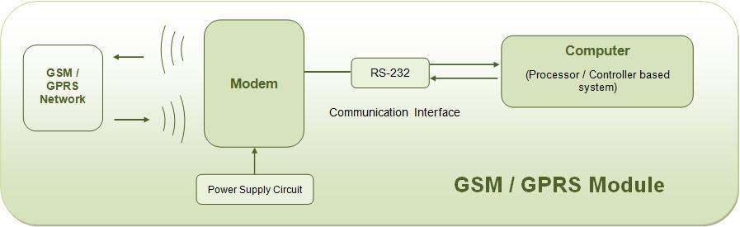

**3.10.4 Wireless MODEMs**

Wireless MODEMs are the MODEM devices that generate, transmit or decode data from a cellular network, for establishing communication between the cellular network and the computer. These are manufactured for specific cellular network (GSM/UMTS/[CDMA](http://www.engineersgarage.com/articles/cdma-technology)) or specific cellular data standard (GSM/UMTS/GPRS/[EDGE](http://www.engineersgarage.com/articles/what-is-edge-technology)/HSDPA) or technology ([GPS](http://www.engineersgarage.com/articles/global-positioning-system-gps)/SIM). Wireless MODEMs like other MODEM devices **use serial communication** to interface with and need **Hayes compatible**[**AT commands**](http://www.engineersgarage.com/tutorials/at-commands) for communication with the computer (any microprocessor or microcontroller system).

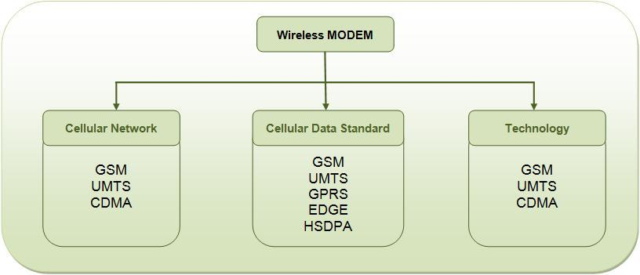

**3.10.5 GSM/GPRS MODEM**

GSM/GPRS MODEM is a class of wireless MODEM devices that are designed for communication of a computer with the GSM and GPRS network. It requires a **SIM (Subscriber Identity Module)** card just like mobile phones to activate communication with the network. Also they have **IMEI**(International Mobile Equipment Identity) number similar to mobile phones for their identification. A GSM/GPRS MODEM can perform the following operations:

1.      Receive, send or delete SMS messages in a SIM.

2.      Read, add, search phonebook entries of the SIM.

3.      Make, Receive, or reject a voice call.

The MODEM needs **AT commands**, for interacting with processor or controller, which are communicated through serial communication. These commands are sent by the controller/processor. The MODEM sends back a result after it receives a command. Different AT commands supported by the MODEM can be sent by the processor/controller/computer to interact with the **GSM and GPRS cellular network**.

A GSM modem is one of the wireless modem that is devised to work with a GSM wireless network. It works with the same frequency of GSM wireless network. It is an important part of the GSM network. Now a days GSM based cell phones are more preferred than cdma phones, hence let us see its operation and its features. The GSM wireless modem works in the way like a dial-up modem. The main difference between the GSM modem and dial up modem is that a dial-up modem sends and receives data through a fixed telephone line while a GSM wireless modem sends and receives data through radio wave propagation.   
Operations that can be performed using GSM modem:

1. We can read, write and delete SMS messages.  
2. We can start Sending SMS messages.  
3. We can reply to a SMS message.  
4. We can monitor the signal strength in particular locality.  
5. We can monitor the charging status and also the charge level in the battery.  
6. We can read, write and search phone book entries.  
7. We can use it in various projects for different purposes.

Like a GSM mobile phone, a GSM modem requires a SIM card from a wireless carrier in order to operate. As mentioned in earlier sections of this SMS tutorial, computers use AT commands to control modems. Both GSM modems and dial-up modems support a common set of standard AT commands. You can use a GSM modem just like a dial-up modem.

In addition to the standard AT commands, GSM modems support an extended set of AT commands. These extended AT commands are defined in the GSM standards. With the extended AT commands, you can do things like:

* Reading, writing and deleting SMS messages.
* Sending SMS messages.
* Monitoring the signal strength.
* Monitoring the charging status and charge level of the battery.
* Reading, writing and searching phone book entries.

The number of SMS messages that can be processed by a GSM modem per minute is very low -- only about six to ten SMS messages per minute.

**What is a concatenated SMS message?** A concatenated SMS message is a message that contains more than 140 bytes. (A normal SMS message can only contain at most 140 bytes.) Concatenated SMS works like this: the sender's mobile device breaks a message longer than 140 bytes into smaller parts. Each of these parts are then fitted in a single SMS message and sent to the recipient. When these SMS messages reach the destination, the recipient's mobile device will combine them back to one message.  
**What is the cause of the problem?** When the mobile phone receives the SMS messages that are parts of a concatenated SMS message, it combines them to one message automatically. The correct behaviour should be: when the mobile phone receives the SMS messages that are parts of a concatenated SMS message, it forwards them to the computer without combining them.

Many mobile phone models cannot be used with a computer to receive MMS messages. Because when they receive a MMS notification, they handle it automatically instead of forwarding it to the computer.

A mobile phone may not support some AT commands, command parameters and parameter values. For example, some mobile phones do not support the sending and receiving of SMS messages in text mode. So, the AT command "AT+CMGF=1" (it instructs the mobile phone to use text mode) will cause an error message to be returned. Usually GSM/GPRS modems support a more complete set of AT commands than mobile phones.

Most SMS messaging applications have to be available 24 hours a day. (For example, an SMS messaging application that provides ringtone downloading service should be running all the time so that a user can download ringtones any time he/she wants.) If such SMS messaging applications use mobile phones to send and receive SMS messages, the mobile phones have to be switched on all the time.

**3.10.6 AT COMMANDS:**

AT commands are instructions used to control a modem. AT is the abbreviation of Attention. Every command line starts with "AT" or "at". That's why modem commands are called AT commands. Many of the commands that are used to control wired dial-up modems, such as ATD (Dial), ATA (Answer), ATH (Hook control) and ATO (Return to online data state), are also supported by GSM/GPRS modems and mobile phones. Besides this common AT command set, GSM/GPRS modems and mobile phones support an AT command set that is specific to the GSM technology, which includes SMS-related commands like AT+CMGS (Send SMS message), AT+CMSS (Send SMS message from storage), AT+CMGL (List SMS messages) and AT+CMGR (Read SMS messages).

Note that the starting "AT" is the prefix that informs the modem about the start of a command line. It is not part of the AT command name. For example, D is the actual AT command name in ATD and +CMGS is the actual AT command name in AT+CMGS. However, some books and web sites use them interchangeably as the name of an AT command.

Here are some of the tasks that can be done using AT commands with a GSM/GPRS modem or mobile phone:

Get basic information about the mobile phone or GSM/GPRS modem. For example, name of manufacturer (AT+CGMI), model number (AT+CGMM), IMEI number (International Mobile Equipment Identity) (AT+CGSN) and software version (AT+CGMR).

Send (AT+CMGS, AT+CMSS), read (AT+CMGR, AT+CMGL), write (AT+CMGW) or delete (AT+CMGD) SMS messages and obtain notifications of newly received SMS messages (AT+CNMI).

**Basic Commands and Extended Commands**

There are two types of AT commands: basic commands and extended commands.

Basic commands are AT commands that do not start with "+". For example, D (Dial), A (Answer), H (Hook control) and O (Return to online data state) are basic commands.

Extended commands are AT commands that start with "+". All GSM AT commands are extended commands. For example, +CMGS (Send SMS message), +CMSS (Send SMS message from storage), +CMGL (List SMS messages) and +CMGR (Read SMS messages) are extended commands.

## Check if your GSM phone or modem supports SMS text mode

To check if your modem supports this text mode, you can try the following command:

**AT+CMGF=1 <ENTER>**

If the modem responds with "OK" this mode is supported. Please note that using this mode it is only possible to send simple text messages. It is not possible to send multipart, Unicode, data and other types of messages.

## Setting up the modem

If the modem contains a SIM card with is secured with a PIN code, we have to enter this pin code first:

**AT+CPIN="0000" <ENTER>** (replace 0000 with your PIN code).

Please not that in most cases you have only 3 attemps to set the correct PIN code. After setting the PIN code, wait some seconds before issueing the next command to give the modem some time to register with the GSM network.

In order to send a SMS, the modem has to be put in SMS text mode first using the following command:

To send the SMS message, type the following command:

**AT+CMGS="+31638740161" <ENTER>**

Replace the above phone number with your own cell phone number. The modem will respond with:

**>**

You can now type the message text and send the message using the <CTRL>-<Z> key combination:

**Hello World ! <CTRL-Z>**

After some seconds the modem will respond with the message ID of the message, indicating that the message was sent correctly:

**+CMGS: 62**

The message will arrive on the mobile phone shortly.

**3.11 BUZZER DRIVER CIRCUIT:**

Digital systems and microcontroller pins lack sufficient current to drive the circuits like relays, buzzer circuits etc. While these circuits require around 10milli amps to be operated, the microcontroller’s pin can provide a maximum of 1-2milli amps current. For this reason, a driver such as a power transistor is placed in between the microcontroller and the buzzer circuit.

**CONTROLLER**

PIN

Vcc

BUZZER

GROUND

The operation of this circuit is as follows:

The input to the base of the transistor is applied from the microcontroller port pin P1.0. The transistor will be switched on when the base to emitter voltage is greater than 0.7V (cut-in voltage). Thus when the voltage applied to the pin P1.0 is high i.e., P1.0=1 (>0.7V), the transistor will be switched on and thus the buzzer will be ON.

When the voltage at the pin P1.0 is low i.e., P1.0=0 (<0.7V) the transistor will be in off state and the buzzer will be OFF. Thus the transistor acts like a current driver to operate the buzzer accordingly.

### POWERSUPPLY

A power supply is a device that converts the output from an ac power line to a steady dc output or multiple outputs. The ac voltage is first rectified to provide a pulsating dc and then filtered to produce a smooth voltage. A 5V power supply is an electrical device that supplies electric power to an electrical load .The source power may come from the electric power grid, such as an electrical outlet, energy storage devices such as batteries or fuel cells, generators or alternators, solar power converters, or another power supply. The purposes of a Power Supply are as follows

* Convert AC to DC.
* Provide DC voltage to the mother board, adapters, and peripheral devices.
* Provide cooling and facilitate air flow through the case.

**3.12.1 INTRODUCTION**

There are many types of power supply. Most are designed to convert high voltage AC mains electricity to a suitable low voltage supply for electronics circuits and other devices. A power supply can by broken down into a series of blocks, each of which performs a particular function. For example a 5V regulated supply can be shown as below

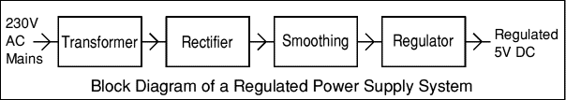

**Fig 3.10: Block Diagram of a Regulated Power Supply System**

Similarly, 12v regulated supply can also be produced by suitable selection of the individual elements. Each of the blocks is described in detail below and the power supplies made from these blocks are described below with a circuit diagram and a graph of their output:

**3.12.2 Transformer:**

A transformer steps down high voltage AC mains to low voltage AC. Here we are using a center-tap transformer whose output will be sinusoidal with 36volts peak to peak value.

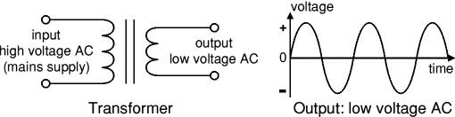

**Fig3.11: Output Waveform of transformer**

The low voltage AC output is suitable for lamps, heaters and special AC motors. It is not suitable for electronic circuits unless they include a rectifier and a smoothing capacitor. The transformer output is given to the rectifier circuit.

**3.12.3 Rectifier:**

A rectifier converts AC to DC, but the DC output is varying. There are several types of rectifiers;here we use a bridge rectifier.

The Bridge rectifier is a circuit, which converts an ac voltage to dc voltage using both half cycles of the input ac voltage. The Bridge rectifier circuit is shown in the figure. The circuit has four diodes connected to form a bridge. The ac input voltage is applied to the diagonally opposite ends of the bridge. The load resistance is connected between the other two ends of the bridge.

For the positive half cycle of the input ac voltage, diodes D1 and D3 conduct, whereas diodes D2 and D4 remain in the OFF state. The conducting diodes will be in series with the load resistance RL and hence the load current flows through RL.

For the negative half cycle of the input ac voltage, diodes D2 and D4 conduct whereas, D1 and D3 remain OFF. The conducting diodes D2 and D4 will be in series with the load resistance RL and hence the current flows through RL in the same direction as in the previous half cycle. Thus a bi-directional wave is converted into unidirectional.

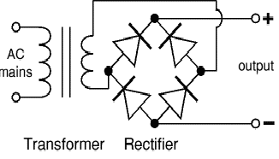

**Fig 3.12 Figure Rectifier circuit**

Now the output of the rectifier shown in Figure 3.3 is shown below in Figure 3.4

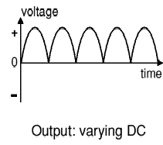

**Fig: 3.13 Output of the Rectifier**

The varying DC output is suitable for lamps, heaters and standard motors. It is not suitable for lamps, heaters and standard motors. It is not suitable for electronic circuits unless they include a smoothing capacitor.

* + 1. **Smoothing:**

The smoothing block smoothes the DC from varying greatly to a small ripple and the *ripple voltage* is defined as the deviation of the load voltage from its DC value. Smoothing is also named as filtering.

Filtering is frequently effected by shunting the load with a capacitor. The action of this system depends on the fact that the capacitor stores energy during the conduction period and delivers this energy to the loads during the no conducting period. In this way, the time during which the current passes through the load is prolonging Ted, and the ripple is considerably decreased. The action of the capacitor is shown with the help of waveform.

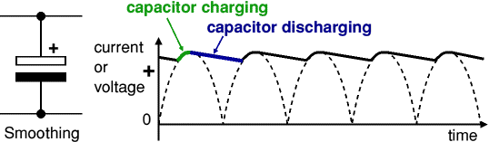

##### **Fig: 3.14 Smoothing action of capacitor**

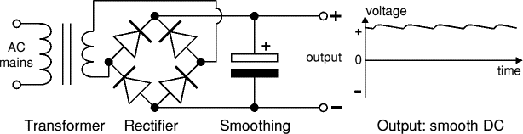

**Figure Waveform of the rectified output smoothing**

**3.12.4 Regulator:**

Regulator eliminates ripple by setting DC output to a fixed voltage. Voltage regulator ICs are available with fixed (typically 5V, 12V and 15V) or variable output voltages. Negative voltage regulators are also available

Many of the fixed voltage regulator ICs has 3 leads (input, output and high impedance). They include a hole for attaching a heat sink if necessary. Zener diode is an example of fixed regulator which is shown here.

|  |  |
| --- | --- |
|  |  |

Fig3.15 Regulator

**Transformer + Rectifier + Smoothing + Regulator**:

**3.13 LED**

# A light-emitting diode is a semiconductor light source that emits light when current flows through it. Electrons in the semiconductor recombine with electron holes, releasing energy in the form of photons. Typically, the forward voltage of an LED is between 1.8 and 3.3 volts. It varies by the color of the LED. A red LED typically drops around 1.7 to 2.0 volts, but since both voltage drop and light frequency increase with band gap, a blue LED may drop around 3 to 3.3 volts. The color of the light is determined by the energy required for electrons to cross the [band gap](https://en.wikipedia.org/wiki/Band_gap) of the semiconductor. White light is obtained by using multiple semiconductors or a layer of light-emitting [phosphor](https://en.wikipedia.org/wiki/Phosphor) on the semiconductor device. LEDs have many advantages over incandescent light sources, including lower power consumption, longer lifetime, improved physical robustness, smaller size, and faster switching. The disadvantages of LEDs include electrical limitations to low voltage and generally to DC (not AC) power.

# 

# Fig: LED image and Symbol

# 

Fig: LED Interfacing circuit

### 3.14 CIRCUIT DIAGRAM AND CONNECTIONS

For designing IoT Based Patient Health Monitoring System using Arduino, assemble the circuit as follows.

* + - Connect the LED to Digital Pin7 of Arduino via a 220-ohm resistor.
    - Connec tPin 1,3,5,16 of LCD to GND and connect Pin2,15 of LCD to VCC.
    - Connect Pin 4,6,11,12,13,14 of LCD to Digital Pin12,11,5,4,3,2 of Arduino.
    - The RX pin ofESP8266 works on 3.3Vand it will not communicate with the Arduino when we will connect it directly to the Arduino.
    - So, we will have to make a voltage divider for it which will convert the5V into 3.3V.
    - This can be done byconnecting the2.2K& 1K resistor.
    - Thus,theRXpinoftheESP8266isconnectedtopin10ofArduinothroughtheresistors.
    - ConnecttheTXpinof theESP8266to pin 9oftheArduino.
    - HereisanotherversionoftheSchematicdesignedusingEasyEDAsoftware.Insteadofusing Arduino UNO,wecan useArduino Nano forthis project.
    - WritethecodeinEmbeddedC ProgrammingLanguage.
    - Simplycopy thecodeand pasteit to yourArduino IDE.
    - Thencompileit andupload itto theArduino UNOBoard.
    - ByprovidingthepowersupplytoArduinoBoard,observetheoutputinLCD,ThingSpeakCloud Platformand Serial monitorin ArduinoIDESoftware

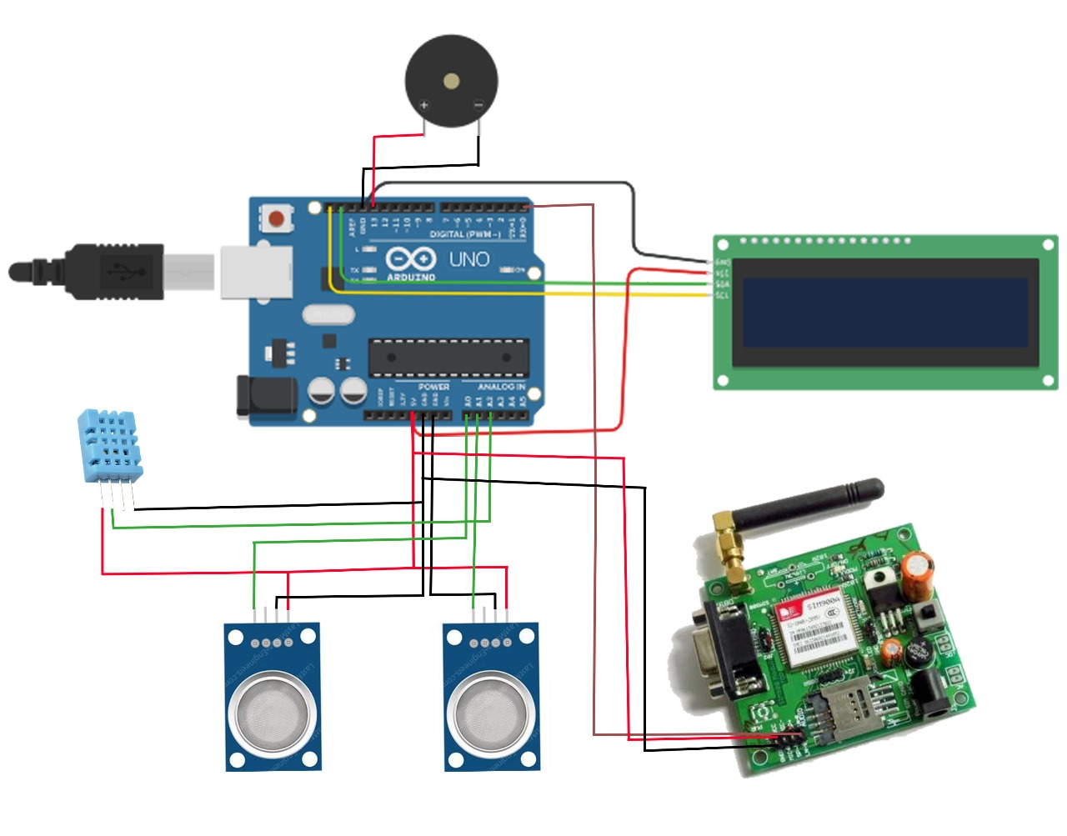**Fig-3.22:** Circuit Diagram of proposed system

### 3.15 ADVANTAGES

### Enhanced Sensitivity: Nanotechnology enables sensors to detect even trace amounts of toxic gases, improving early warning capabilities.

### Remote Monitoring: Wireless sensors allow for remote and real-time monitoring of toxic gases in inaccessible or hazardous environments.

### Miniaturization: Nanotech-based sensors can be miniaturized, enabling their integration into compact and portable monitoring devices.

### Rapid Response Time: Nanotechnology facilitates rapid detection and response to toxic gas incidents, reducing potential harm.

### Cost Efficiency: Despite initial investment, nanotech sensors can offer long-term cost savings through reduced maintenance and operational expenses.

### Data Accuracy: Wireless sensors coupled with nanotechnology provide accurate and reliable data, aiding in effective decision-making and response strategies.

### Scalability: The scalability of wireless sensor networks allows for the deployment of numerous sensors over large areas, enhancing coverage and monitoring capabilities.

### Environmental Monitoring: Nanotech sensors can also be used for environmental monitoring beyond toxic gases, providing multifunctional utility.

### APPLICATIONS

* Nanotechnology-based sensors offer unparalleled sensitivity, detecting even minute concentrations of toxic gases, ensuring early detection and prevention of hazards.
* Miniaturization facilitated by nanotechnology allows for the creation of compact and portable wireless sensors, enabling their deployment in diverse environments for continuous monitoring.
* Real-time monitoring capabilities provided by wireless sensors enable instant data collection on gas concentrations, facilitating prompt responses to changing environmental conditions.
* The integration of nanotechnology and wireless sensors leads to cost-effective monitoring solutions, with reduced production costs and minimal installation expenses due to wireless connectivity.

**CHAPTER-4**

**RESOURCES USED**

**CHAPTER-4**

**RESOURCES USED**

### ARDUINOIDE

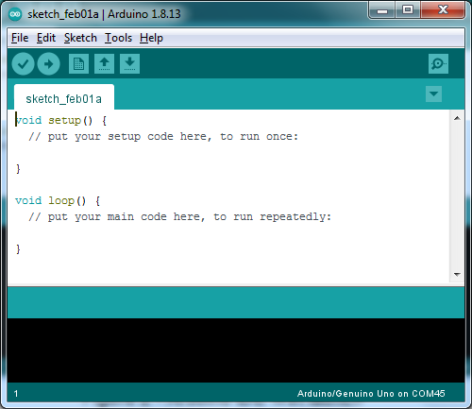The Arduino Integrated Development Environmentor Arduino Software (IDE)**containsa text editor for writing code, a message area, a text console, a toolbar with buttons for common functions and a series of menus**. It connects to the Arduino hardware to upload programs and communicate with them. The **Arduino** [**IDE**](https://en.m.wikipedia.org/wiki/Integrated_development_environment) is a [cross-platform](https://en.m.wikipedia.org/wiki/Cross-platform) application(for [Windows,](https://en.m.wikipedia.org/wiki/Windows) [Linux](https://en.m.wikipedia.org/wiki/Linux)) that is written in functions from [C](https://en.m.wikipedia.org/wiki/C_(programming_language)) and [C++.](https://en.m.wikipedia.org/wiki/C%2B%2B_(programming_language))It is used to write and upload programs to [Arduino](https://en.m.wikipedia.org/wiki/Arduino) compatible boards with the help of third-party cores and other vendor development boards.

**Fig-4.1:**ArduinoIDE

### WRITINGSKETCHES

Programs written using Arduino Software (IDE) are called **sketches**. These sketches are written in the text editor and are saved with the file extension .ion. The editor has features for cutting/pasting and for searching/replacing text. The message area gives feedback while saving and exporting and also displays errors. The console displays text output by the Arduino Software (IDE), including complete error messages and other information. The bottom right and corner of the window displays the configured board and serial port. The tool bar buttons allow you to verify and upload programs, create, open, and save sketches, and open the serial monitor.

* Verify Checks your code for errors compiling it.IDE VERIFY File
* Upload Compiles your code and uploads it to the configured board.

**Note:** If you are using an external programmer with your board, you can hold down the "shift" key on your computer when using this icon. The text will change to "Upload using Programmer".

* New Creates a new sketch.
* OpenPresentsamenuofallthesketchesinyoursketchbook.Clickingonewillopenitwithinthecurrentwindowoverwritingitscontent.
* Note: due to a bugin Java ,this menu doesn't scroll; if you need to open a sketch late in the list, use the **File Sketchbook** menu instead.
* Save Saves your sketch.
* Serial Monitor Opens the [serial monitor](https://docs.arduino.cc/software/ide-v1/tutorials/arduino-ide-v1-basics#serial-monitor).

Additional commands are found within the menus: **File**, **Edit**, **Sketch**, **Tools**, **Help**. The menus are context sensitive, which means only those items relevant to the work currently being carried out are available.

### FILE

* **New**- Creates a new instance of the editor, with the bare minimum structure of a sketchalreadyinplace.
* **Open**-Allowstoloadasketchfilebrowsingthroughthecomputerdrivesandfolders.
* **OpenRecent-**Providesashortlistofthemostrecentsketches,readytobeopened.
* **Sketchbook-** Showsthecurrentsketcheswithinthesketchbookfolderstructure;clickingonanynameopensthecorrespondingsketchinaneweditorinstance.
* **Examples**-AnyexampleprovidedbytheArduinoSoftware(IDE)orlibraryshowsupin this menu item. All the examples are structured in a tree that allows easy access bytopicorlibrary.
* **Close-**ClosestheinstanceoftheArduinoSoftwarefromwhichitisclicked.
* **Save**- Saves the sketch withthe currentname.If the file hasn'tbeennamedbefore,anamewillbeprovidedina"Saveas"window.
* **Saveas-**Allowstosavethecurrentsketchwithadifferentname.
* **PageSetup-**ItshowsthePageSetupwindowforprinting.
* **Print-** Sends the current sketch to the printer according to the settings defined in PageSetup.
* **Preferences-** Opens the Preferences window where some settings of the IDE may becustomized,asthelanguageoftheIDEinterface.
* **Quit-** Closes all IDE windows. The same sketches open when Quit was chosen will beautomaticallyreopenedthenexttimeyoustarttheIDE.

### EDIT

* **Undo/Redo-**Goesbackofoneormorestepsyoudidwhileediting;whenyougoback,youmaygoforwardwithRedo.
* **Cut-**Removestheselectedtextfromtheeditorandplacesitintotheclipboard.
* **Copy-**Duplicatestheselectedtextintheeditorandplacesitintotheclipboard.
* **CopyforForum-**Copiesthecodeofyoursketchtotheclipboardinaformsuitableforpostingtotheforum,completewithsyntaxcoloring.
* **CopyasHTML-**CopiesthecodeofyoursketchtotheclipboardasHTML,suitableforembeddinginwebpages.
* **Paste-**Putsthecontentsoftheclipboardatthecursorposition,intheeditor.
* **SelectAll-**Selectsandhighlightsthewholecontentoftheeditor.
* **Comment/Uncomment**-Putsorremovesthe//commentmarkeratthebeginningofeachselectedline.
* **Increase/DecreaseIndent-**Addsorsubtractsaspaceatthebeginningofeachselectedline,movingthetextonespaceontherightoreliminatingaspaceatthebeginning.
* **Find-**OpenstheFindandReplacewindowwhereyoucanspecifytexttosearchinsidethecurrentsketchaccordingtoseveraloptions.
* **FindNext-**Highlightsthenextoccurrence-ifany-ofthestringspecifiedasthesearchitemintheFindwindow,relativetothecursorposition.
* **FindPrevious**-Highlightsthepreviousoccurrence-ifany-ofthestringspecifiedasthesearchitemintheFindwindowrelativetothecursorposition.

### SKETCH

* **Verify/Compile-** Checksyoursketchforerrorscompilingit;itwillreportmemoryusageforcodeandvariablesintheconsolearea.
* **Upload-** CompilesandloadsthebinaryfileontotheconfiguredboardthroughtheconfiguredPort.
* **Upload Using Programmer**- This will overwrite the bootloader on the board; you willneed to use Tools > Burn Bootloader to restore itand be able to Upload to USBserialport again. However, it allows you to use the full capacity of the Flash memory for yoursketch.PleasenotethatthiscommandwillNOTburnthefuses.TodosoaTools->BurnBootloadercommandmustbeexecuted.
* **Export Compiled Binary-** Saves a .hex file that may be kept as archive or sent to theboardusingothertools.
* **ShowSketchFolder-**Opensthecurrentsketchfolder.
* **Include Library-** Adds a library to your sketch by inserting #include statements at thestartofyourcode.Additionally,fromthismenuitemyoucanaccesstheLibraryManagerandimportnewlibrariesfrom.zipfiles.
* **Add File-** Adds a supplemental file to the sketch (it will be copied from its currentlocation). The file is saved to the Data sub folder of the sketch, which is intended forassets suchas documentation. The contents of the datafolder are notcompiled, so theydonot become part of thesketch program.

### TOOLS

* **Auto Format-** This formats your code nicely i.e., indents it so that opening and closingcurlybraceslineupandthatthestatementsinsidecurlybracesareindentedmore.
* **Archive Sketch-** Archives a copy of the current sketch in .zip format. The archive isplacedinthesamedirectoryasthesketch.
* **FixEncoding& Reload-** Fixespossible discrepanciesbetweenthe editor char mapencodingandotheroperatingsystemscharmaps.
* **SerialMonitor-** Opens theserialmonitorwindowand initiatesthe exchangeofdatawithanyconnectedboardonthecurrentlyselectedPort.Thisusuallyresetstheboard,iftheboardsupportsResetoverserialportopening.
* **Port-**Thismenucontainsalltheserialdevices(realorvirtual)onyourmachine.Itshouldautomaticallyrefresheverytimeyouopenthetop-leveltoolsmenu.
* **Programmer-** ForselectingahardwareprogrammerwhenprogrammingaboardorchipandnotusingtheonboardUSB-serialconnection.Normallyyouwon'tneedthis,butifyou're[burningabootloader](https://docs.arduino.cc/built-in-examples/arduino-isp/ArduinoISP)toanewmicrocontroller,youwillusethis.
* **BurnBootloader-** Theitemsinthismenuallowyoutoburna [bootloader](https://docs.arduino.cc/hacking/software/Bootloader) ontothemicrocontroller on an Arduino board. This is not required for normal use of an ArduinoboardbutisusefulifyoupurchaseanewATmegamicrocontroller(whichnormallycomewithoutabootloader).Ensurethatyou'veselectedthecorrectboardfromthe **Boards** menu before burning the bootloader on the target board. This command alsosettherightfuses.

### HELP

HereyoufindeasyaccesstoanumberofdocumentsthatcomewiththeArduinoSoftware (IDE). You have access to Getting Started, Reference, this guide to the IDE and otherdocumentslocally,withoutaninternetconnection.The documentsare a localcopyoftheonlineonesandmaylinkbacktoouronlinewebsite.

### SKETCHBOOK

The Arduino Software (IDE) uses the concept of a sketchbook which is a standard placetostore yourprograms (orsketches).The sketchesinyoursketchbook canbe openedfromthe**File>Sketchbook**menuorfromthe**Open**buttononthetoolbar.Thefirsttimeyourun

theArduinosoftware,itwillautomaticallycreateadirectoryforyoursketchbook.Youcanvieworchangethelocationofthesketchbooklocationfromwiththe**Preferences**dialog.

### UPLOADING

Before uploading your sketch, you need to select the correct items from the **Tools >Board**and**Tools>Port**menus.Thenselecttheserialportandboard.Onceyou'veselectedthecorrectserialport and board, press the upload button in the toolbar or selectthe **Upload** item from the **Sketch** menu. Current Arduino boards will reset automatically andbegintheupload.

### LIBRARIES

Libraries provide extra functionality for use in sketches, e.g. working with hardware ormanipulatingdata.Tousealibraryinasketch,selectitfromthe **Sketch>ImportLibrary** menu. This will insert one or more **#include** statements at the top of the sketch andcompile the library with your sketch. Because libraries are uploaded to the board with yoursketch,theyincrease the amount of space ittakesup.If a sketchnolonger needsa library,simplydeleteits**#include**statementsfromthetopofyourcode.

### SERIALMONITOR

This displays serial sent from the Arduino board over USB or serial connector. To senddata to the board, enter text and click on the "send" button or press enter. Choose the baud ratefromthedrop-downmenuthatmatchestheratepassedto**Serial.begin**inyoursketch.NotethatonWindows, Mac or Linux the boardwillreset (itwill rerunyour sketch) when youconnectwiththeserialmonitor.

### EMBEDDEDCLANGUAGE

Embedded C is most popular programming language in software field for developingelectronicgadgets.Eachprocessorusedinelectronicsystemisassociatedwithembeddedsoftware.EmbeddedCprogrammingplaysakeyroleinperformingspecificfunctionbythe

processor. In day-to-day life we used many electronic devices such as mobile phone, washingmachine, digital camera, etc. The working of allthese devices is based on microcontroller thatare programmed by embedded C. Embedded C is a generic term given to a programminglanguage written in C, which is associated with a particular hardware architecture.Embedded C is an extension to the C language with some additional header files.Theseheaderfilesmaychangefromcontroller tocontroller.

The embedded system designers must know about the hardware architecture towrite programs. These programs play a prominent role in monitoring and controllingexternal devices. They also directly operate and use the internal architecture of themicrocontroller, such as interrupt handling, timers, serial communication, and otheravailable features. In embedded system programming C code is preferred over other language.Duetothefollowing reasons:

* Easytounderstand
* HighReliability
* Portability
* Scalability

### EMBEDDED SYSTEM PROGRAMMING

Aswediscussedearlier,thedesigningofanembeddedsystemcanbedoneusingHardware & Software. For instance, in a simple embedded system, the processor is the mainmodule that works like the heart of the system. Here a processor is nothing but a microprocessor,DSP, microcontroller, CPLD & FPGA. All these processors are programmable so that it definestheworkingofthedevice.AnEmbeddedsystemprogramallowsthehardwaretochecktheinputs & control outputs accordingly. In this procedure, the embedded program may have tocontrol the internal architecture of the processor directly like Timers, Interrupt Handling, I/OPorts,serial communications interface, etc.

In every embedded system-based projects, Embedded C programming plays a key role tomakethemicrocontrollerrun&performthepreferredactions.Atpresent,wenormallyutilize

several electronic devices like mobile phones, washing machines, security systems, refrigerators,digital cameras, etc. The controlling of these embedded devices can be done with the help of anembedded C program. For example, in a digital camera, if we press a camera button to capture aphoto then the microcontroller will execute the required function to click the image as well as tostoreit.

Embedded C programming builds with a set of functions where every function is a set ofstatementsthatareutilizedtoexecutesomeparticulartasks.BoththeembeddedCandClanguages are the same and implemented through some fundamental elements like a variable,character set, keywords, data types, declaration of variables, expressions, statements. All theseelementsplay akeyrole while writing ­­­­­an embedded C program.

So embedded system programming is very important to the processor. There are differentprogramming languages are available for embedded systems such as C, C++, assembly language,JAVA, JAVA script, visual basic, etc. So this programming language plays a key role whilemakingan embedded system but choosing thelanguageisveryessential.

### MAINFACTORSOF EMBEDDEDCPROGRAM

Themainfactorstobeconsideredwhilechoosingtheprogramminglanguagefordevelopinganembeddedsystem includethe following.

* **ProgramSize:**Everyprogramminglanguageoccupiessomememorywhereembeddedprocessorlikemicrocontrollerincludesanextremelylessamountofrandom-access memory.
  + - **Speed of theProgram:**The programming language should be veryfast, so shouldrun as quickly as possible. The speed of embedded hardware should not be reducedbecauseof theslow-running software.
    - **Portability:**Forthedifferentembeddedprocessors,thecompilationofsimilarprogramscanbedonesuch as
      * 1. SimpleImplementation
        2. SimpleMaintenance
        3. Readability

### STEPS TO BUILD AN EMBEDDED C PROGRAM

There are different steps involved in designing anembedded c program like the following.

* Comments
* Directives of Processor
* Configuration of Port
* Global variables
* Core Function / Main Function
* Declaration of Variable
* The logic of the Program

### BENEFITSOFEMBEDDEDC

* It is effort less to understand.
* It executes a similar task continually, so there is no requirement for changing hardware like additional memory, otherwise storage space.
* It performs merelya single taskat once
* Thecostof thehardware usedintheembeddedcistypicallyso muchlow.
* Theapplicationsof embeddedareincredibly appropriateinindustries.
* Ittakeslesstimeto developanapplicationprogram.
* EmbeddedCcanrunpre-definedprogramming.
* Embedded C is the speed of entering code which provides more accelerated results.

### APPLICATIONSOFEMBEDDEDC

* Speedcontrolleron thehighway
* Commandingoftrafficlightsandcontrollingofstreetlights
* Pursuingthevehicle,artificialintelligence
* Homeautomationandauto intensitycontrol.
* EmbeddedCprogrammingisusedinindustriesfordifferent purposes
* Theprogramminglanguageusedin theapplicationssuchas

­­

# 

# CHAPTER-5

# EXPERIMENTALRESULTS

## CHAPTER-5

## EXPERIMENTALRESULTS

### HARDWARE IMPLEMENTATIONS

Here sensors are being used for detecting the gases present in the air. The sensors data are collected and transmitted the data which is communicated to the Mobile Phone through GSM.

**Fig5.2:** Project bath members

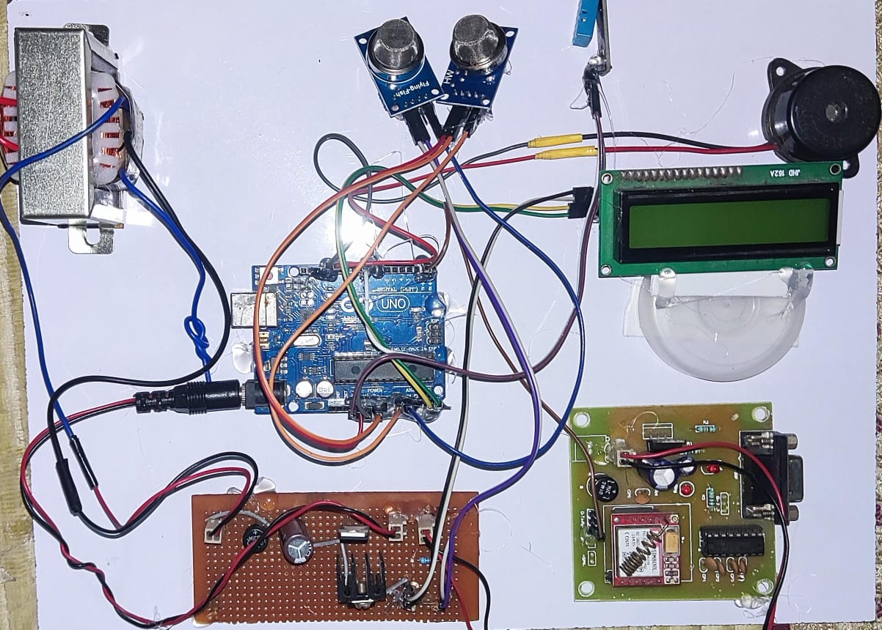

**Fig5.2:** HardwareImplementation

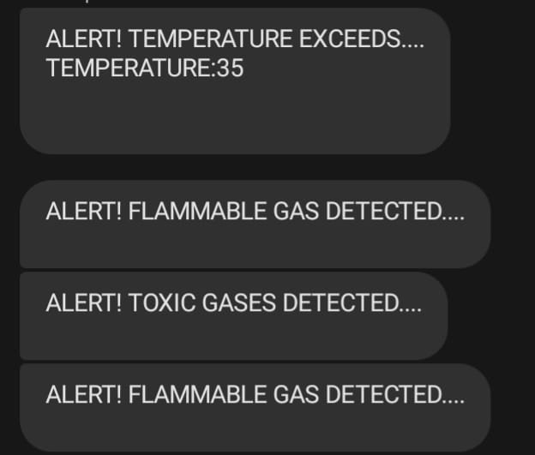

**Fig5.4:** Showing Location of Patient on Mobile

A message is sent to predefined registered mobile number when parameters of temperature, humidity and gases concentration exceed the threshold value. The message will consist of parameter readings.

### APPLICATIONS

* + - Leak Detection in Pipelines: Nanotech Wireless Sensors
    - Corrosion Monitoring for Pipeline Safety: Nanotechnology Solutions
    - Rapid Response to Gas Leaks: Wireless Sensors in Pipelines
    - Remote Monitoring of Pipelines: Nanotech Wireless Sensors
    - Regulatory Compliance in Pipeline Management: Nanotech Sensors
    - Optimizing Pipeline Maintenance with Nanotech Wireless Sensors

### SIGNIFICANCE

* + - Early Detection.
    - Real-Time Monitoring.
    - EaseofDatatransferthrough SMS.
    - Environmental Protection.
    - PublicHealth.

## CONCLUSION

As a result of growing industrialization and concerns about the global impact of air pollution, there is a growing demand for automated gas monitoring and control systems. There are several flaws in traditional methods for evaluating and identifying the presence of numerous different types of gases in a sample.

To address this issue, we designed an dangerous gas monitoring system that will employ several sensors and components, including gas sensors, that can sense a variety of gases: Ammonia, carbon dioxide (CO2), carbon monoxide (CO), nitrogen dioxide (NO2), and sulfur dioxide (SO2) are mostly used for environmental monitoring in the ambient environment.

Finally, we want to conclude that this project is to give immediate dataair condition. This enables the development of highly sensitive, portable, and cost-effective gas sensors with the potential to revolutionize environmental monitoring, public health, and safety practices.

## FUTURESCOPE

Monitoring toxic gases using nanotechnology and wireless sensors presents a promising future scope across various domains including environmental monitoring, industrial safety, healthcare, and defense. Here are some potential future developments and applications in this field:

Future developments may lead to the creation of autonomous monitoring systems equipped with self-powered nanosensors capable of harvesting energy from their environment (e.g., ambient light, vibrations, or chemical reactions). These systems could operate continuously without the need for external power sources, providing long-term monitoring capabilities in remote or inaccessible locations.

Nanotechnology-based gas sensors could play a crucial role in environmental monitoring programs aimed at assessing air quality, detecting pollution sources, and mitigating health risks associated with toxic gases. Such sensors could also be deployed in urban areas, industrial facilities, and indoor environments to safeguard public health and ensure regulatory compliance.

In the context of smart cities, the integration of nanotechnology-based gas sensors into urban infrastructure (e.g., streetlights, traffic signals, and building ventilation systems) could enable real-time monitoring of air quality and early detection of hazardous conditions, contributing to sustainable urban development and resilience planning.

Overall, the future scope of monitoring toxic gases using nanotechnology and wireless sensors holds great potential for addressing pressing societal challenges related to environmental pollution, industrial safety, and public health, paving the way for safer and more sustainable communities.

## BIBLIOGRAPHY

* **M. Y. Aalsalem, W. Z. Khan, W. Gharibi, M. K. Khan, and Q. Arshad, “Wireless sensor networks in oil and gas industry: Recent advances, taxonomy, requirements, and open challenges,”,2018**
* **X. Chao, W. Dargie, and G. Lin, “Energy model for H2S monitoring wireless sensor network,”, 2008**
* **Valera-Medina, H. Xiao, M. Owen-Jones, W. I. David, and P. Bowen, “Ammonia for power,”, 2018**
* **P. Zhao, Z. Li, X. Han, and X. Duan, “Supply chain network resilience by considering disruption propagation: Topological and operational perspectives,”, 2022**
* **H. Yilmazkuday, “Coronavirus disease 2019 and the global economy,”, 2022**
* **B. Zhang, Y. Liu, and S. Qiao, “A quantitative individual risk assessment method in process facilities with toxic gas release hazards: a combined scenario set and cfd approach,”,2019**

**APPENDIX**

### SOURCECODE/PROGRAM

The source code for the project monitoring toxic gases using technology and wireless sensors is given below. Simply copy the code and paste it to your Arduino IDE,thencompile it and upload it to your Arduino UNOBoard.

**#include <dht11.h>**

**#define DHT11PIN 8**

**dht11 DHT11;**

**int t, h;**

**#include <LiquidCrystal_I2C.h>**

**LiquidCrystal_I2C lcd(0X27, 16, 2);**

**int buzz = 13;**

**int mq2 = A0;**

**int mq135 = A1;**

**int mq2_value = 0;**

**int mq135_value = 0;**

**void setup()**

**{**

**Serial.begin(9600);**

**pinMode(buzz, OUTPUT);**

**digitalWrite(buzz, LOW);**

**pinMode(mq2, INPUT);**

**pinMode(mq135, INPUT);**

**lcd.init();**

**lcd.backlight();**

**lcd.clear();**

**lcd.setCursor(0, 0);**

**lcd.print(" TOXIC GASES ");**

**lcd.setCursor(0, 1);**

**lcd.print("MONITORING SYSTEM ");**

**delay(3000);**

**lcd.clear();**

**}**

**void loop()**

**{**

**mq2_value = analogRead(mq2);**

**mq135_value = analogRead(mq135);**

**int chk = DHT11.read(DHT11PIN);**

**h = (float)DHT11.humidity;**

**t = (float)DHT11.temperature;**

**lcd.setCursor(0, 0);**

**lcd.print("M2: ");**

**lcd.setCursor(3, 0);**

**lcd.print(mq2_value);**

**lcd.setCursor(7, 0);**

**lcd.print("M135: ");**

**lcd.setCursor(0x0C, 0);**

**lcd.print(mq135_value);**

**lcd.setCursor(0, 1);**

**lcd.print("TEMP:");**

**lcd.setCursor(5, 1);**

**lcd.print(t);**

**lcd.setCursor(7, 1);**

**lcd.print("C");**

**lcd.setCursor(9, 1);**

**lcd.print("HUM:");**

**lcd.setCursor(0X0D, 1);**

**lcd.print(h);**

**lcd.setCursor(0X0F, 1);**

**lcd.print("%");**

**delay(3000);**

**if (mq2_value >= 200)**

**{**

**digitalWrite(buzz, HIGH);**

**lcd.clear();**

**lcd.setCursor(0, 0);**

**lcd.print("FLAMMABLE GAS");**

**lcd.setCursor(0, 1);**

**lcd.print(" DETECTED ");**

**Serial.println();**

**Serial.print("AT+CMGS="); // Send the SMS number. To whome message to send.**

**Serial.print("\"+917416355929\"");// paste your number**

**Serial.println();**

**delay(500);**

**digitalWrite(buzz, LOW);**

**delay(2000);**

**Serial.print("ALERT! FLAMMABLE GAS DETECTED...."); // SMS-Message body**

**delay(4000);**

**Serial.println();**

**Serial.write(26);**

**lcd.clear();**

**}**

**if (mq135_value >= 400)**

**{**

**digitalWrite(buzz, HIGH);**

**lcd.clear();**

**lcd.setCursor(0, 0);**

**lcd.print(" TOXIC GASES ");**

**lcd.setCursor(0, 1);**

**lcd.print(" DETECTED ");**

**Serial.println();**

**Serial.print("AT+CMGS="); // Send the SMS number. To whome message to send.**

**Serial.print("\"+917416355929\"");// paste your number**

**Serial.println();**

**delay(500);**

**digitalWrite(buzz, LOW);**

**delay(2000);**

**Serial.print("ALERT! TOXIC GASES DETECTED...."); // SMS-Message body**

**delay(4000);**

**Serial.println();**

**Serial.write(26);**

**lcd.clear();**

**}**

**if (t >= 35)**

**{**

**digitalWrite(buzz, HIGH);**

**lcd.clear();**

**lcd.setCursor(0, 0);**

**lcd.print(" TEMPERATURE ");**

**lcd.setCursor(0, 1);**

**lcd.print(" EXCEEDS... ");**

**Serial.println();**

**Serial.print("AT+CMGS="); // Send the SMS number. To whome message to send.**

**Serial.print("\"+917416355929\"");// paste your number**

**Serial.println();**

**delay(500);**

**digitalWrite(buzz, LOW);**

**delay(2000);**

**Serial.print("ALERT! TEMPERATURE EXCEEDS...."); // SMS-Message body**

**Serial.println();**

**Serial.print("TEMPERATURE:");**

**Serial.println(t);**

**delay(4000);**

**Serial.println();**

**Serial.write(26);**

**lcd.clear();**

**}}**